# Evidence for Project Unit

Pauline Cairns

E21

P. 1 Github Contributors page

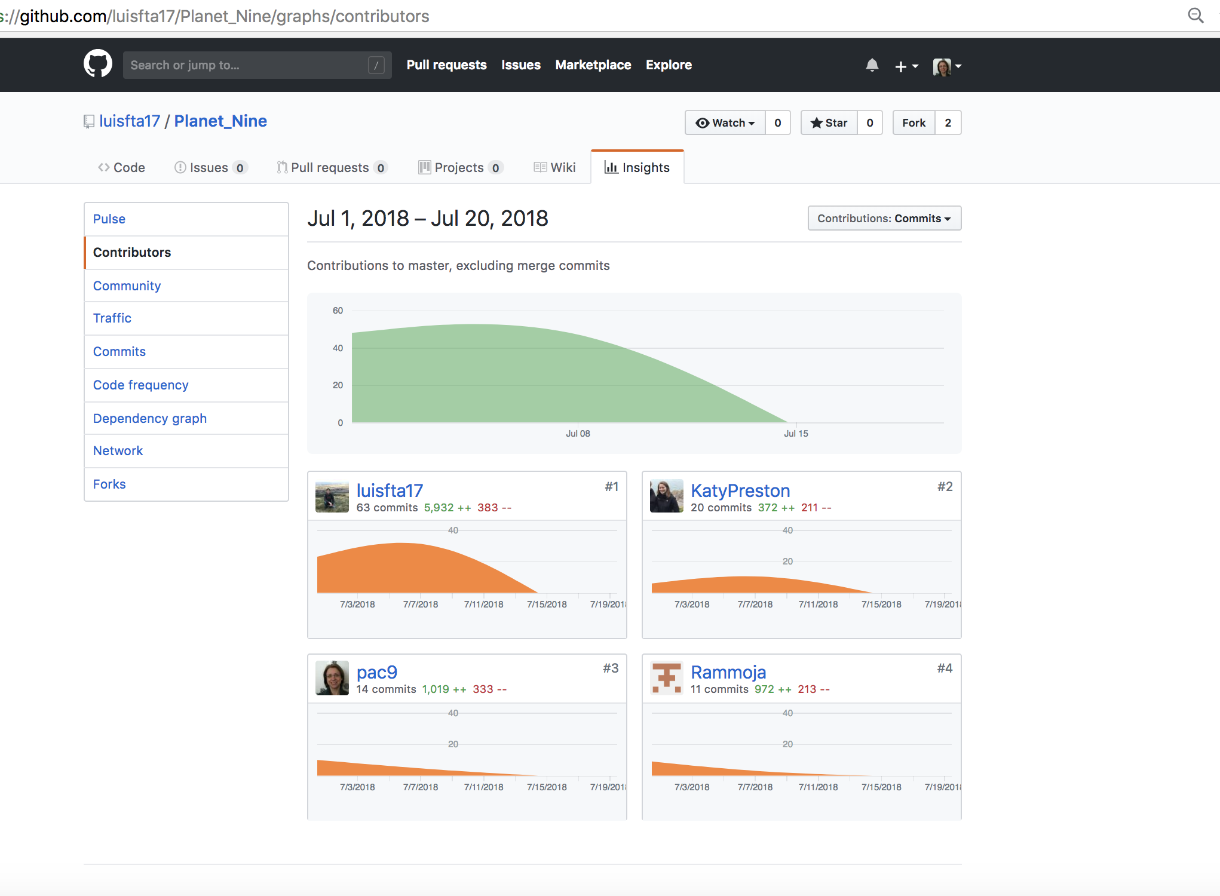

P. 2 Project Brief

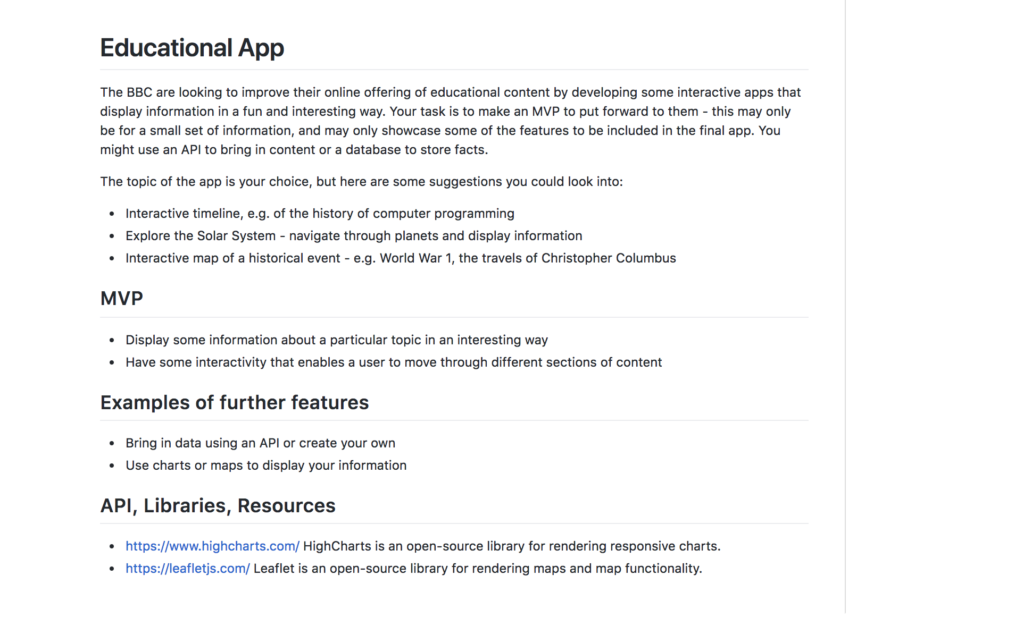

P. 3 Use of Trello

Planets project

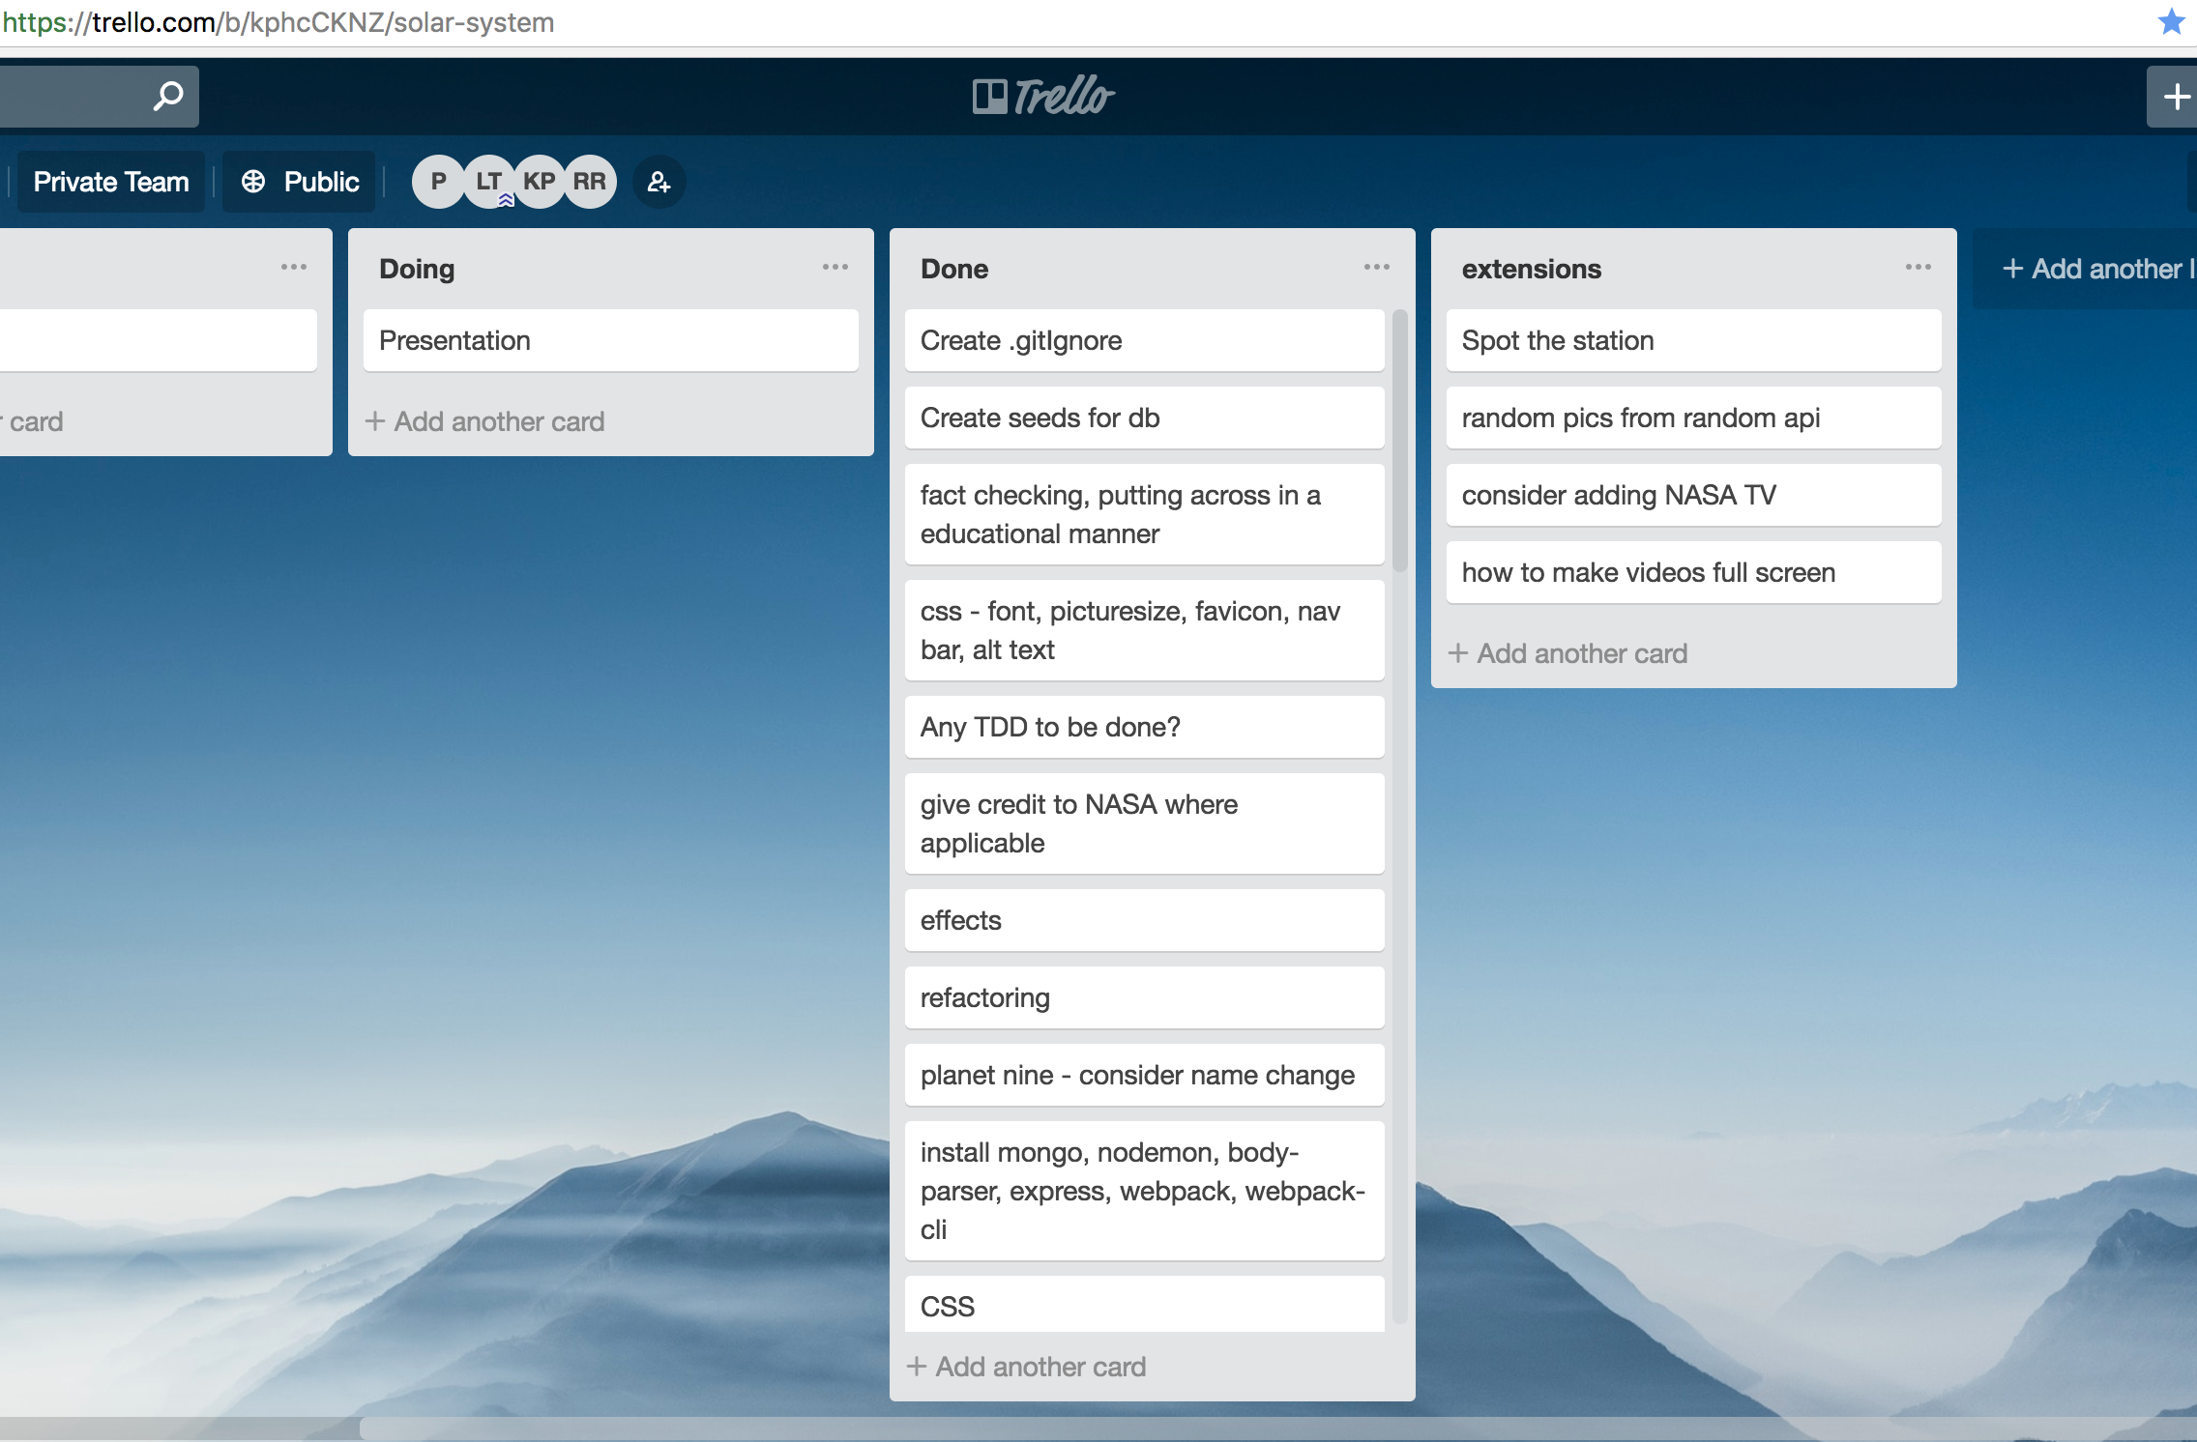

P4 Acceptance Criteria

Planets project

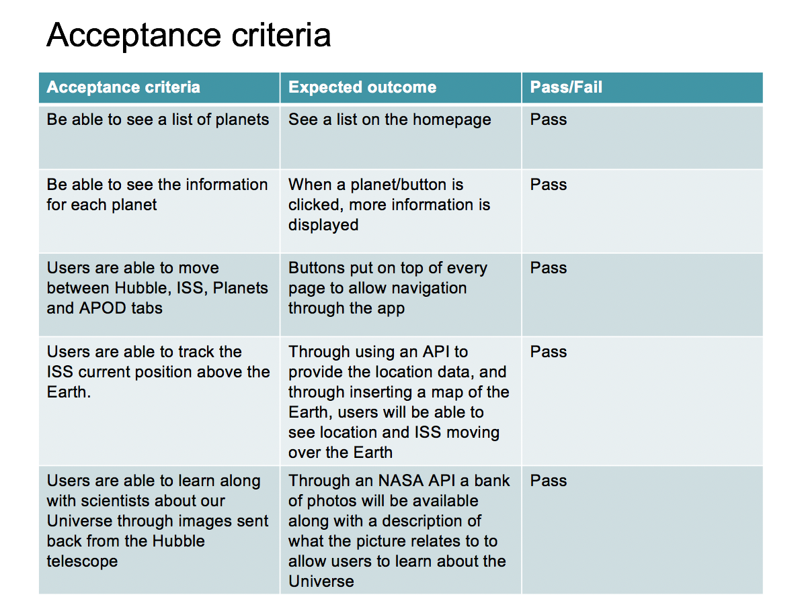

P. 5 User sitemap

Planets project

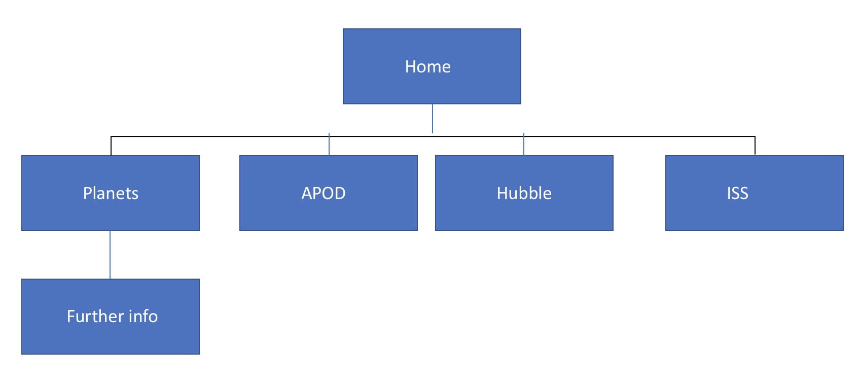

P. 6 Wireframes designs

Group project – Planet Nine

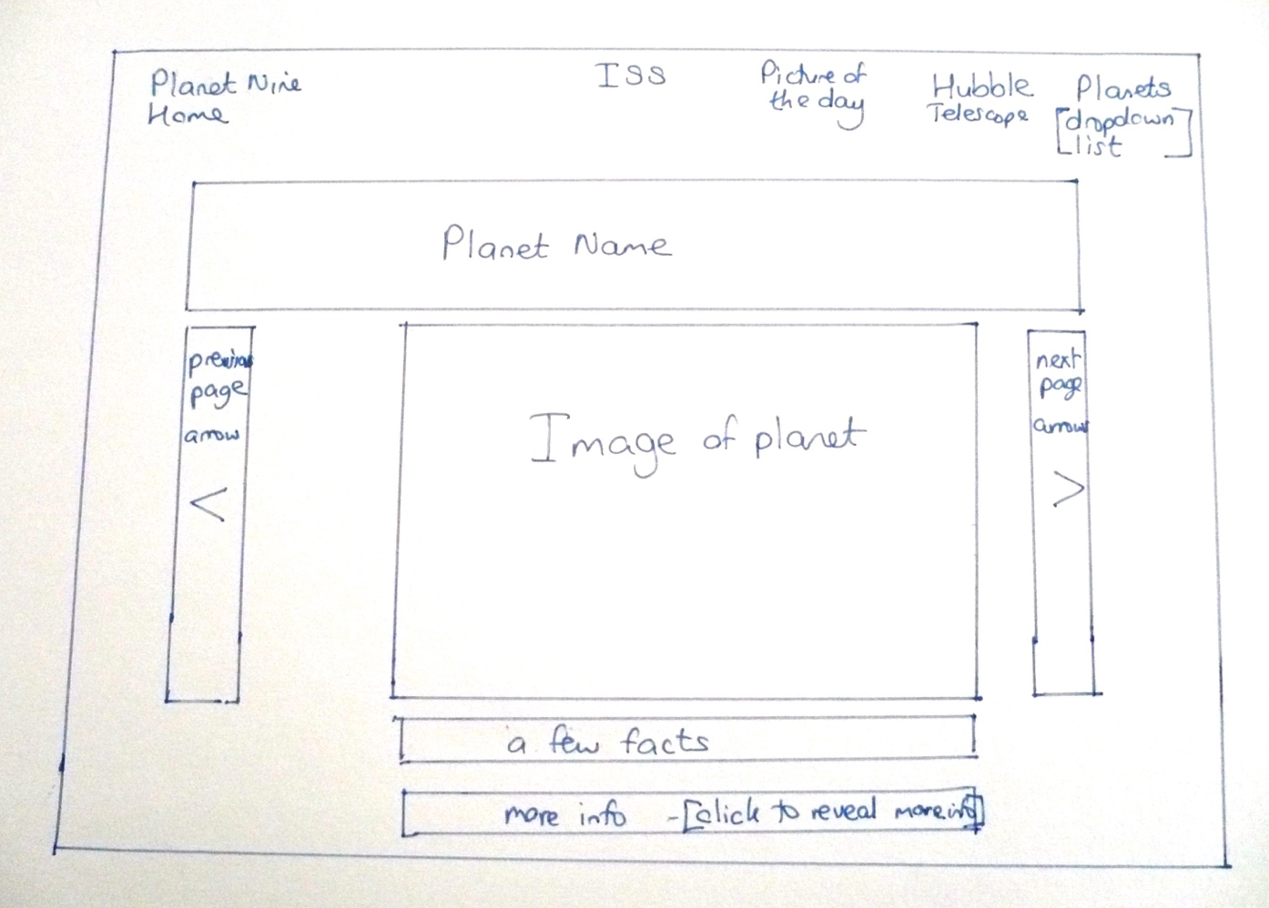

**Stock inventory Ruby project**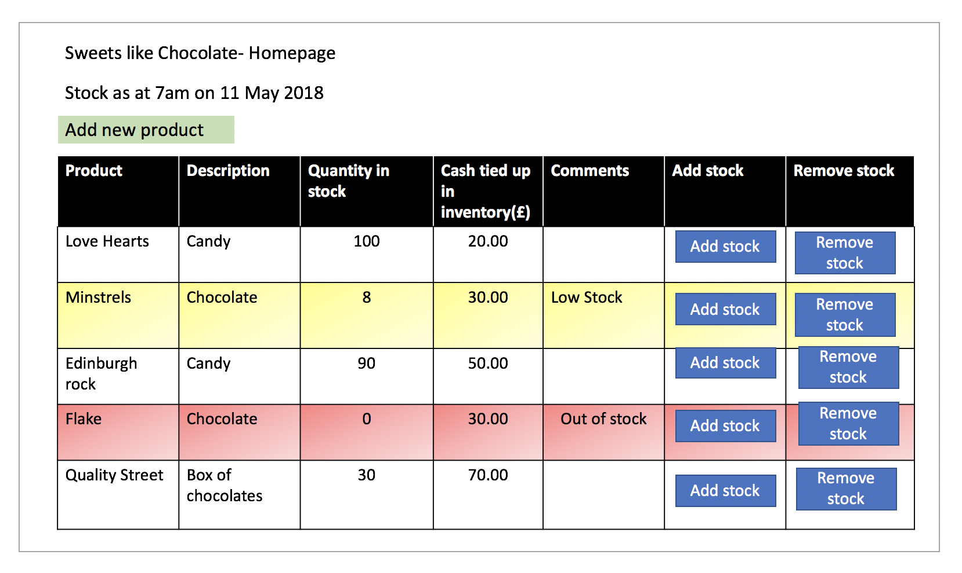

P7 System interactions diagrams

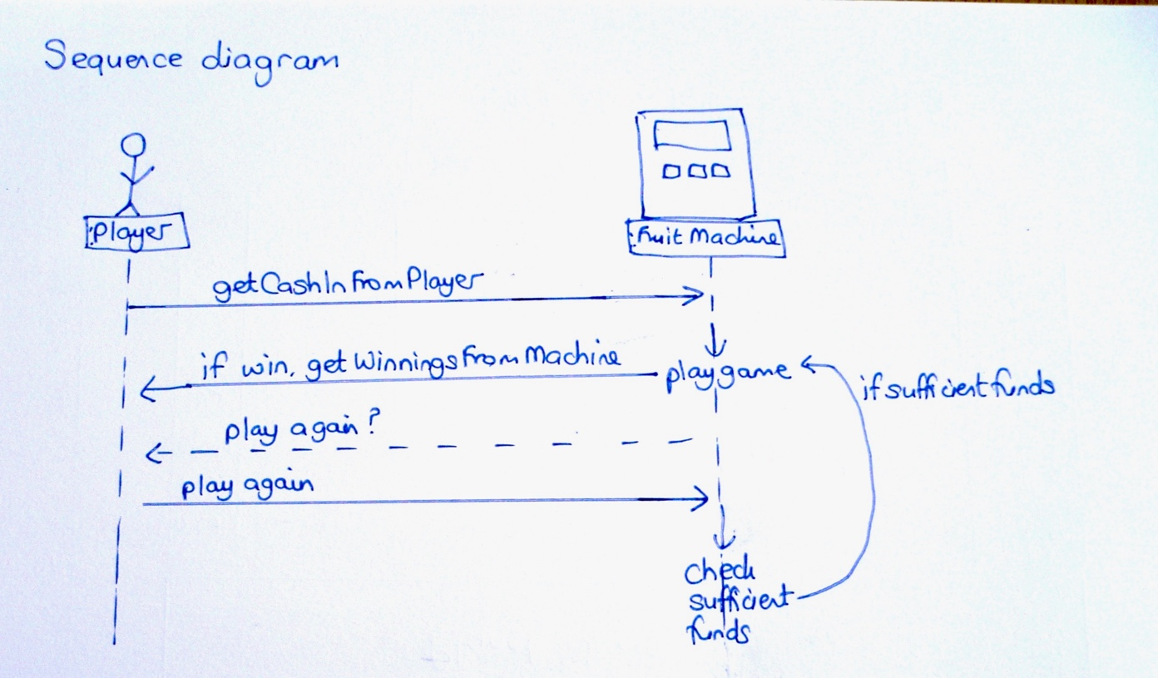

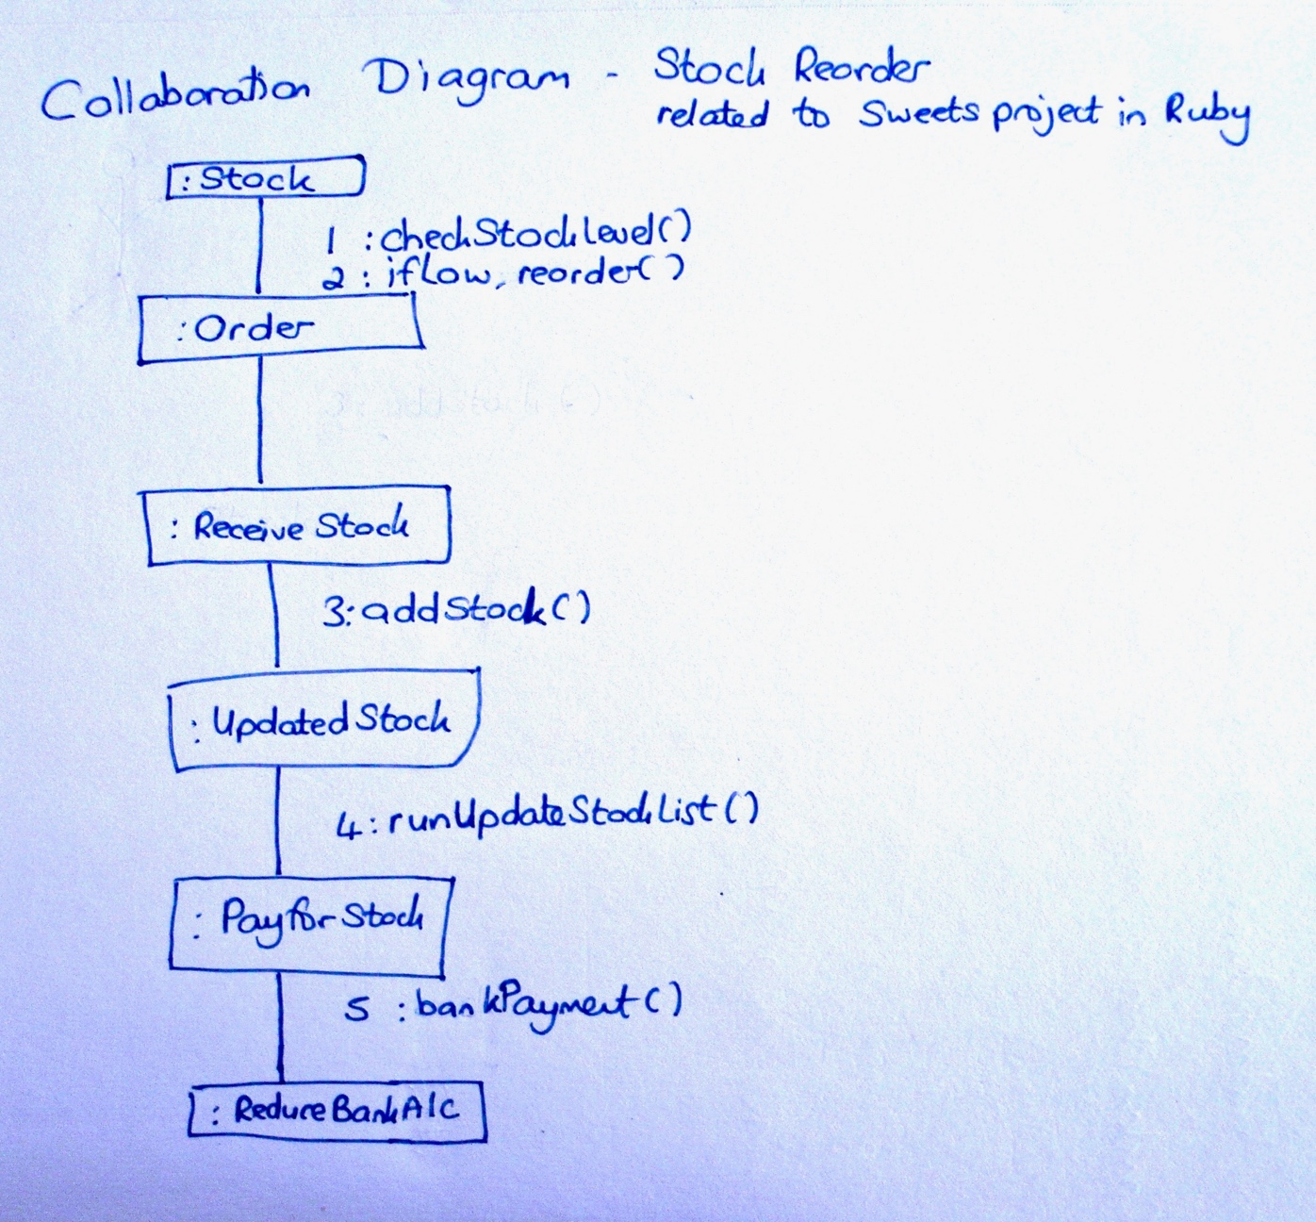

P. 8 Two Object Diagrams

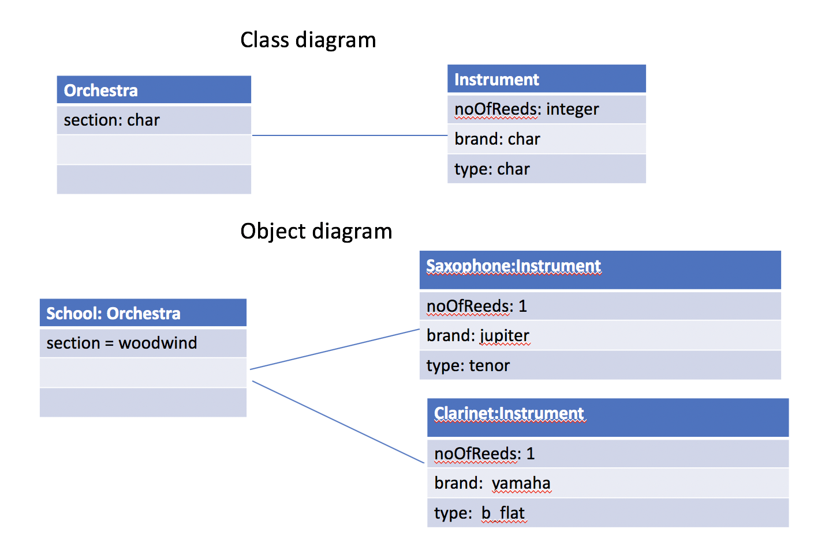

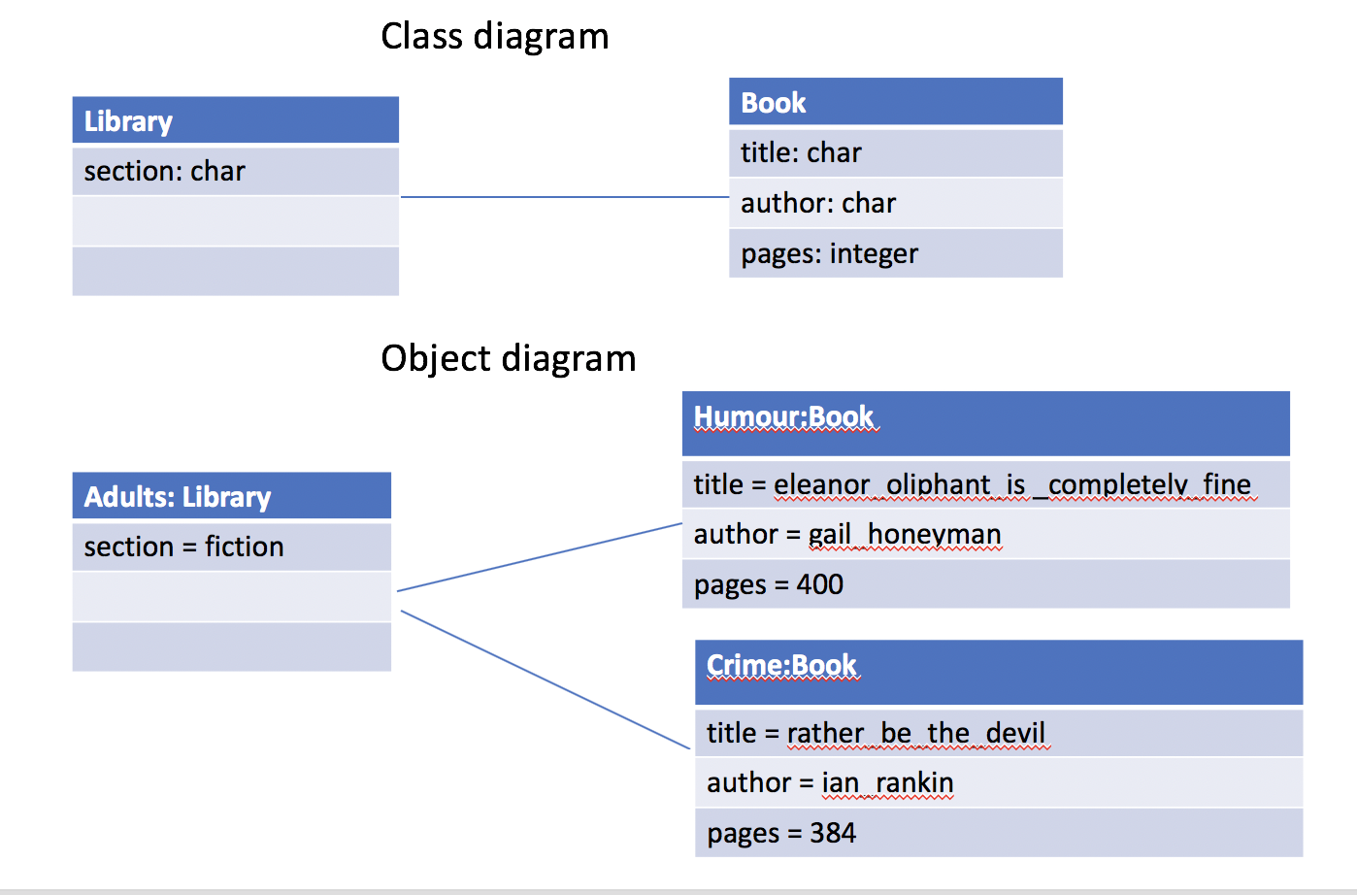

P. 9 Choice of two algorithms (find the algorithms on a program you might have written, show the code you have used. )

On this example please take a screenshot and write what it is doing and why you decided to use it.

Week6 day 1 Homework Single classes

In method pagesUsed, used an algorithm to determine if there was enough sheets of paper in a printer to allow a document to be printed and if there was, for the stock of paper in the printer to be depleted of the amount of paper used.

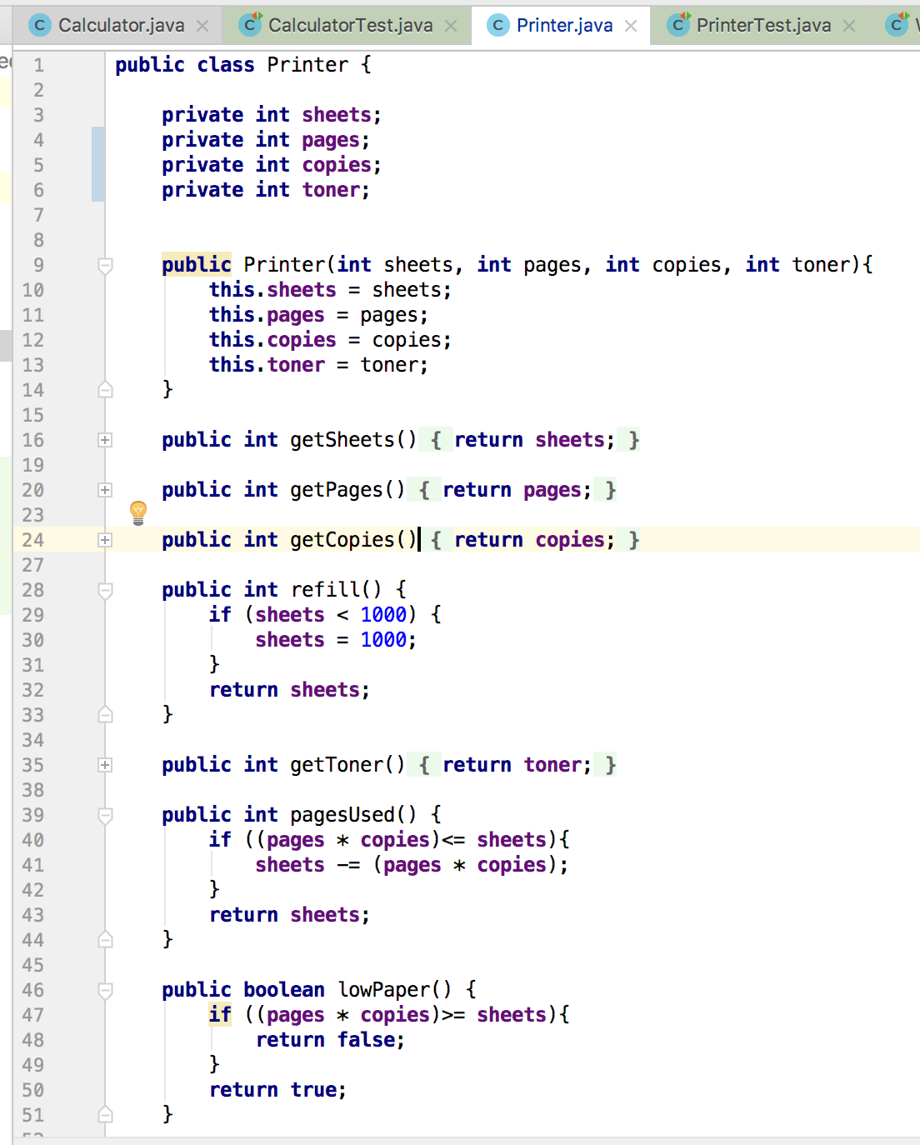

**Week 2 Weekend homework – Karaoke bar**

**An algorithm for a guest to a karaoke bar has sufficient funds to pay the entrance fee and if they have sufficient funds it is taken out of their wallet**

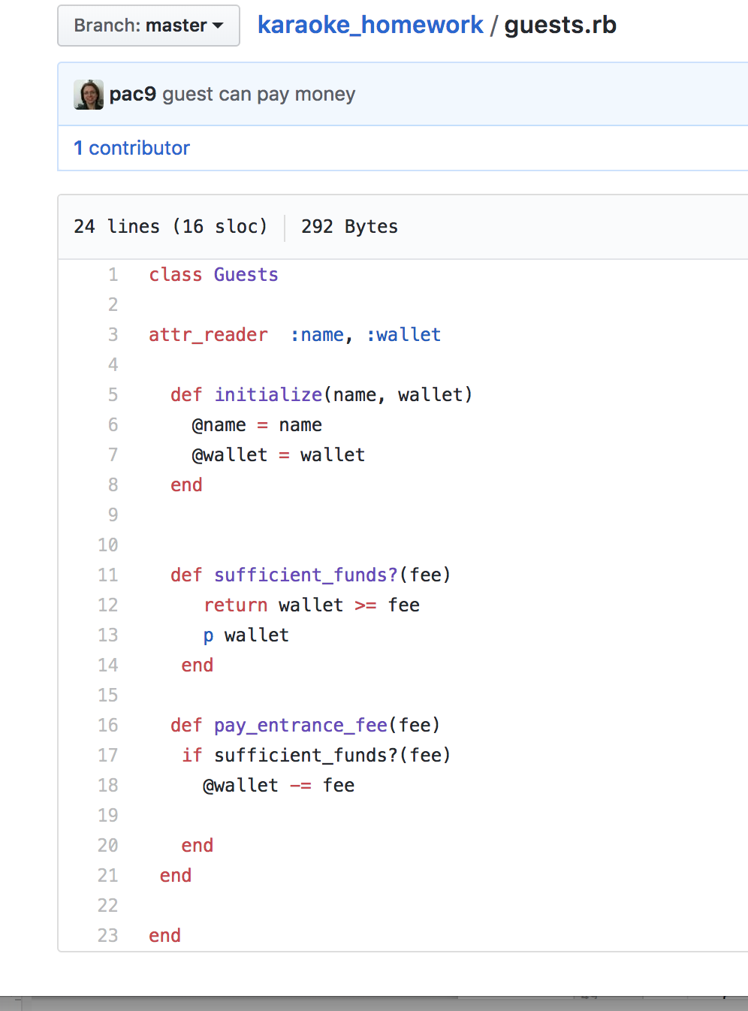

Week12 countries_weekend_homework

P. 10 Example of Pseudocode

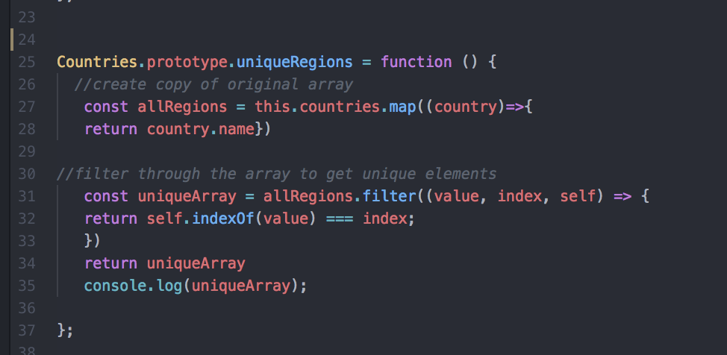

P. 11 Github link to one of your projects

<https://github.com/pac9/FruitMachineJavaProject>

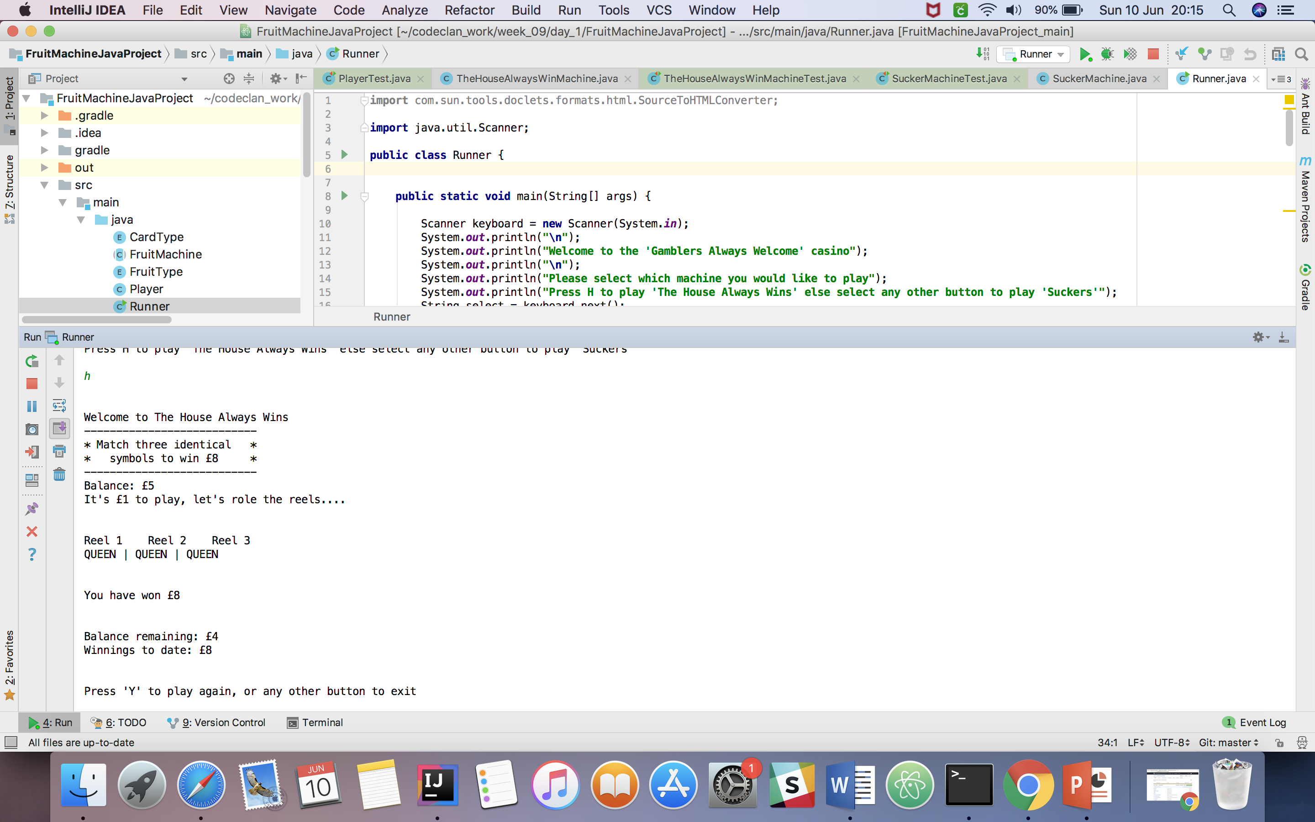

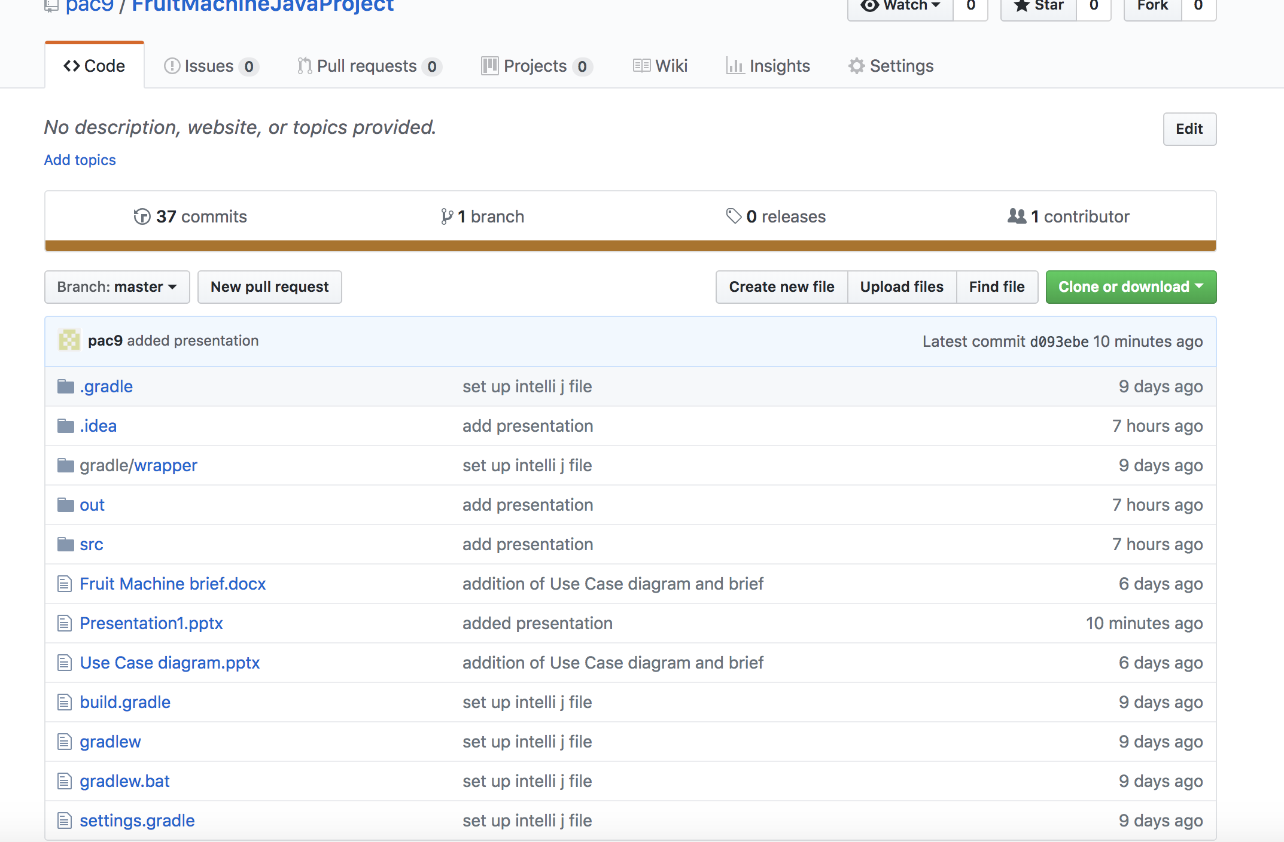

# P. 12 Screenshot of your planning and the different stages of development to show changes.

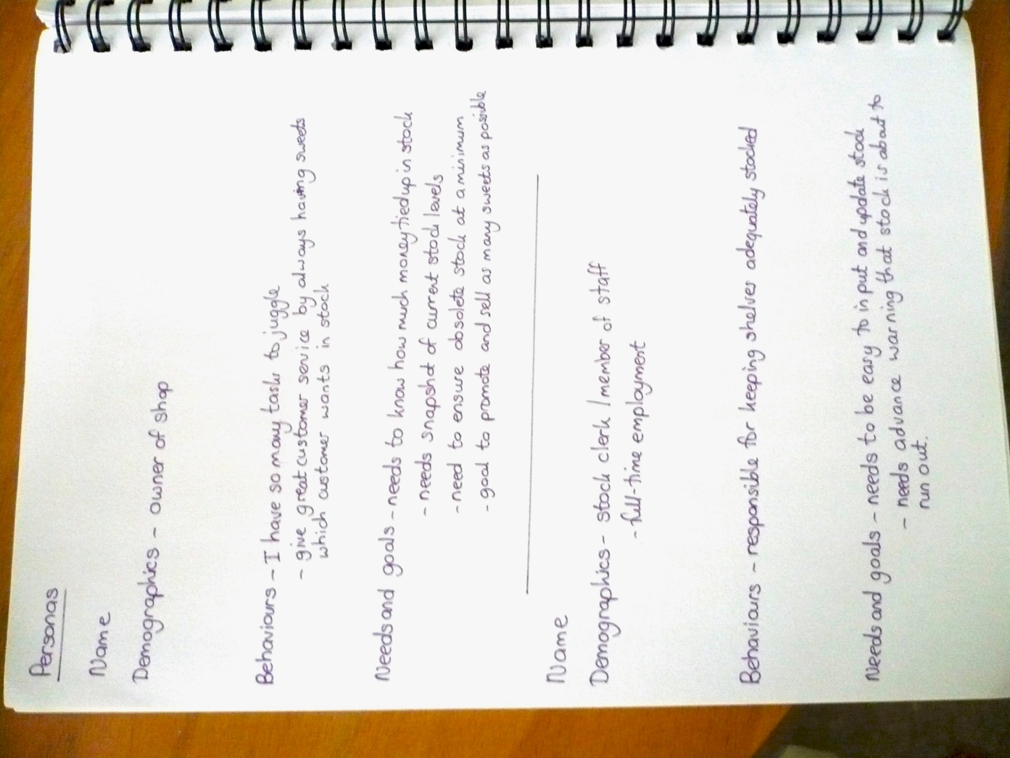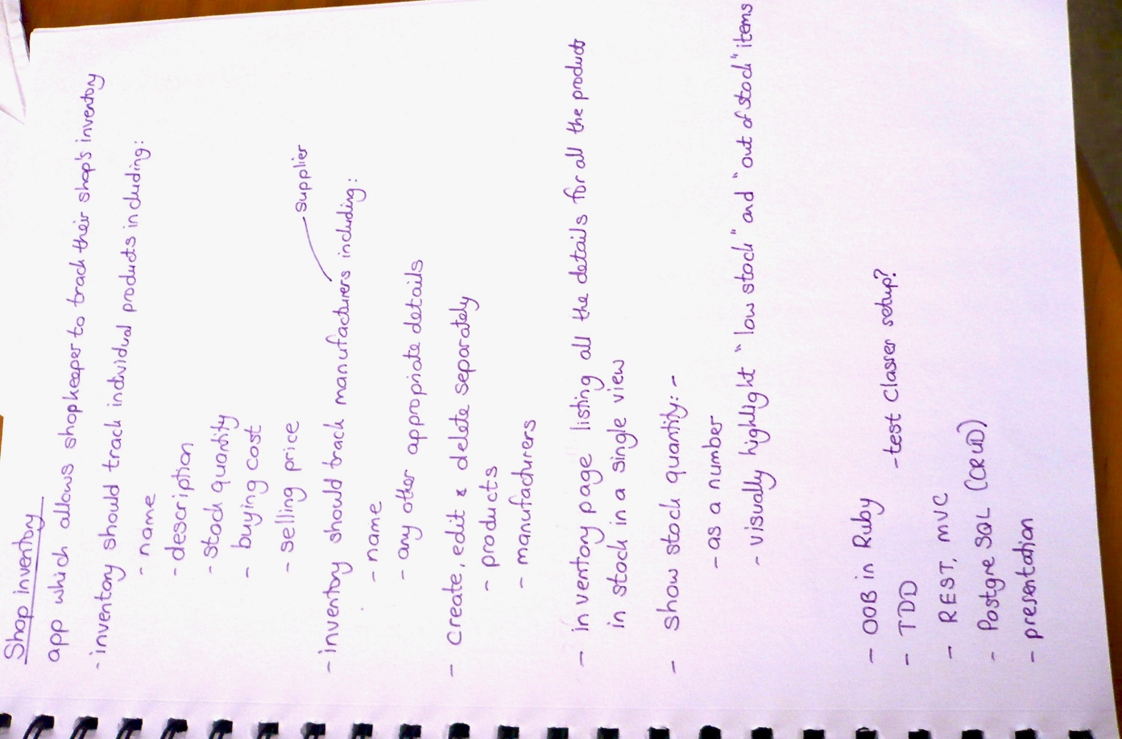

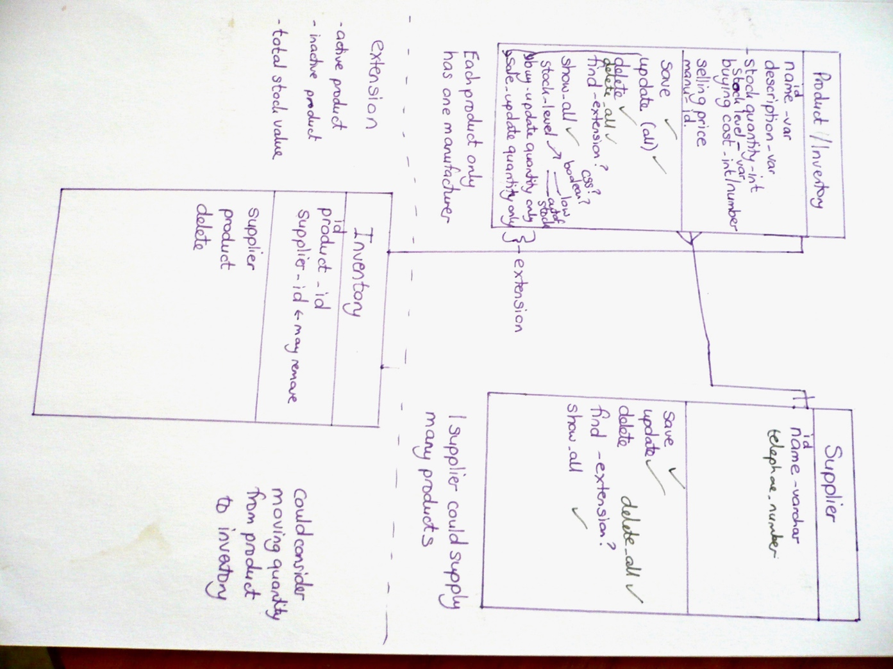

P13

User selects game to play and then decides whether to roll reels again.

**P. 13 User input**

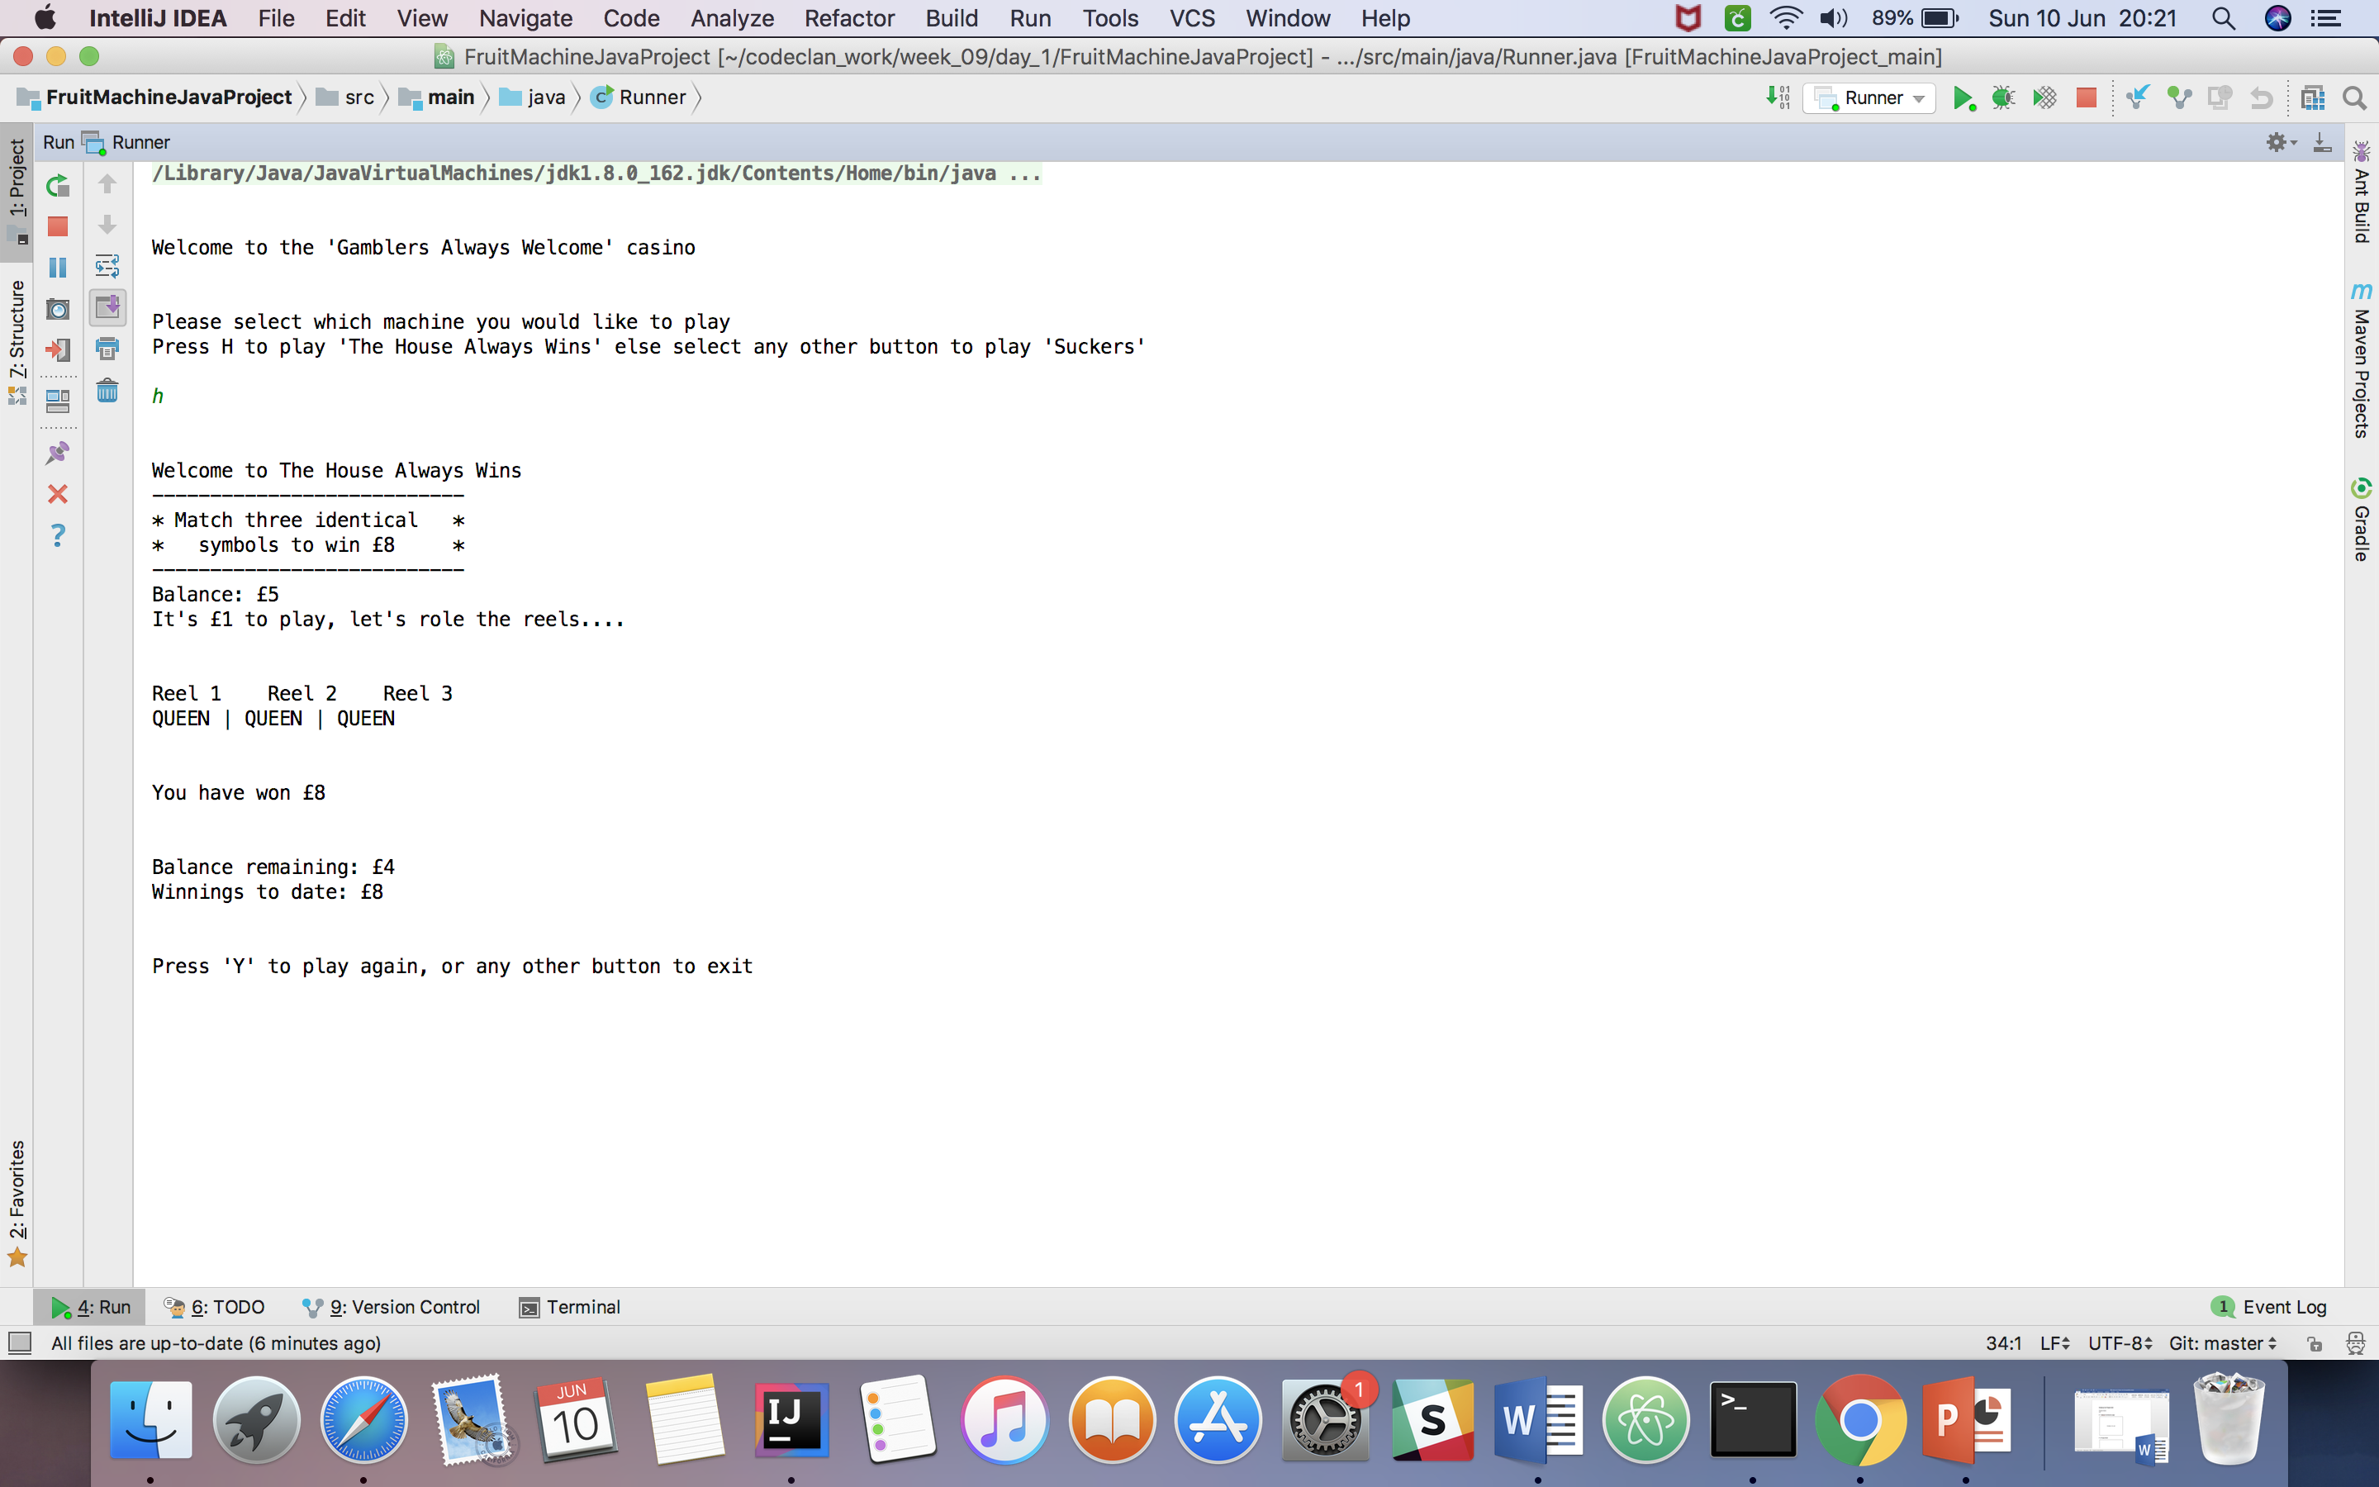

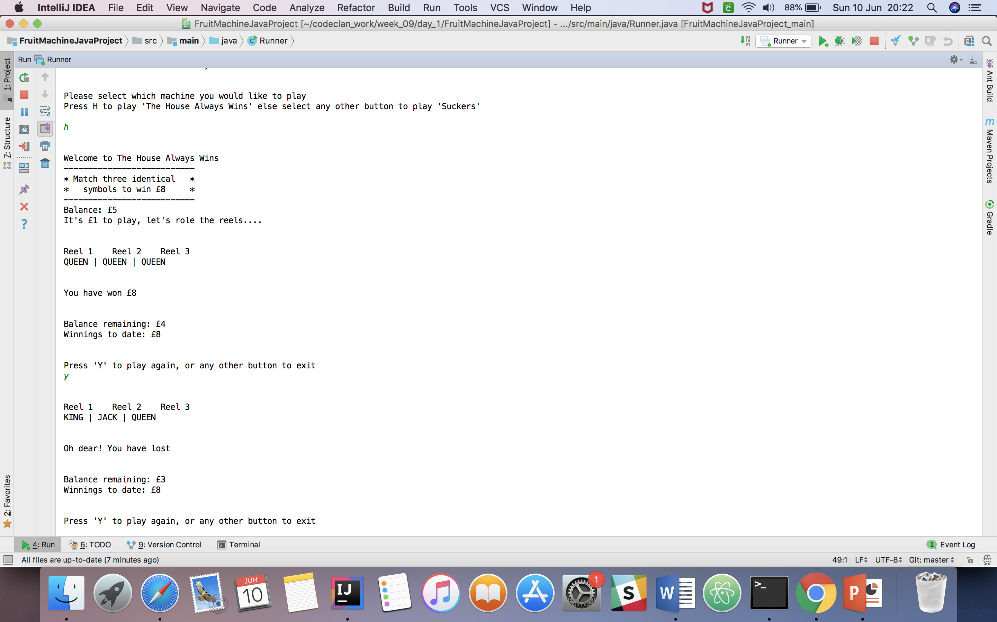

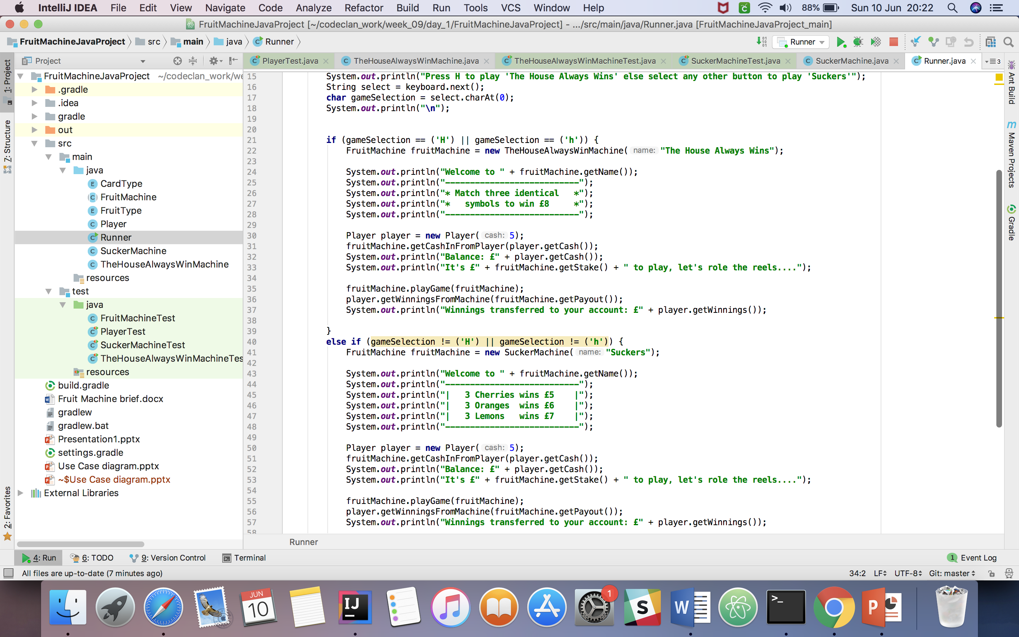

P. 14 Interaction with data persistence

Fruit machine project. Player has cash, cash input is saved, and cash reduces each time the game is played

Player has cash.

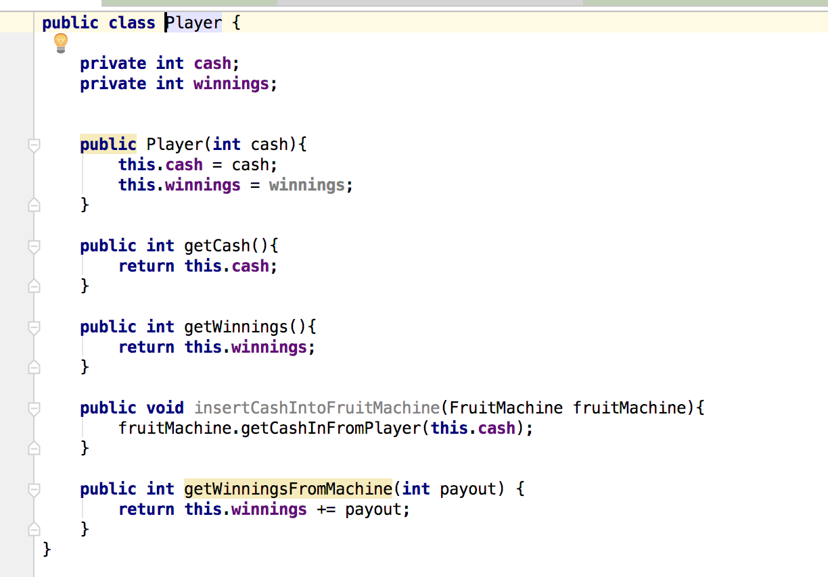

Player cash called in runner

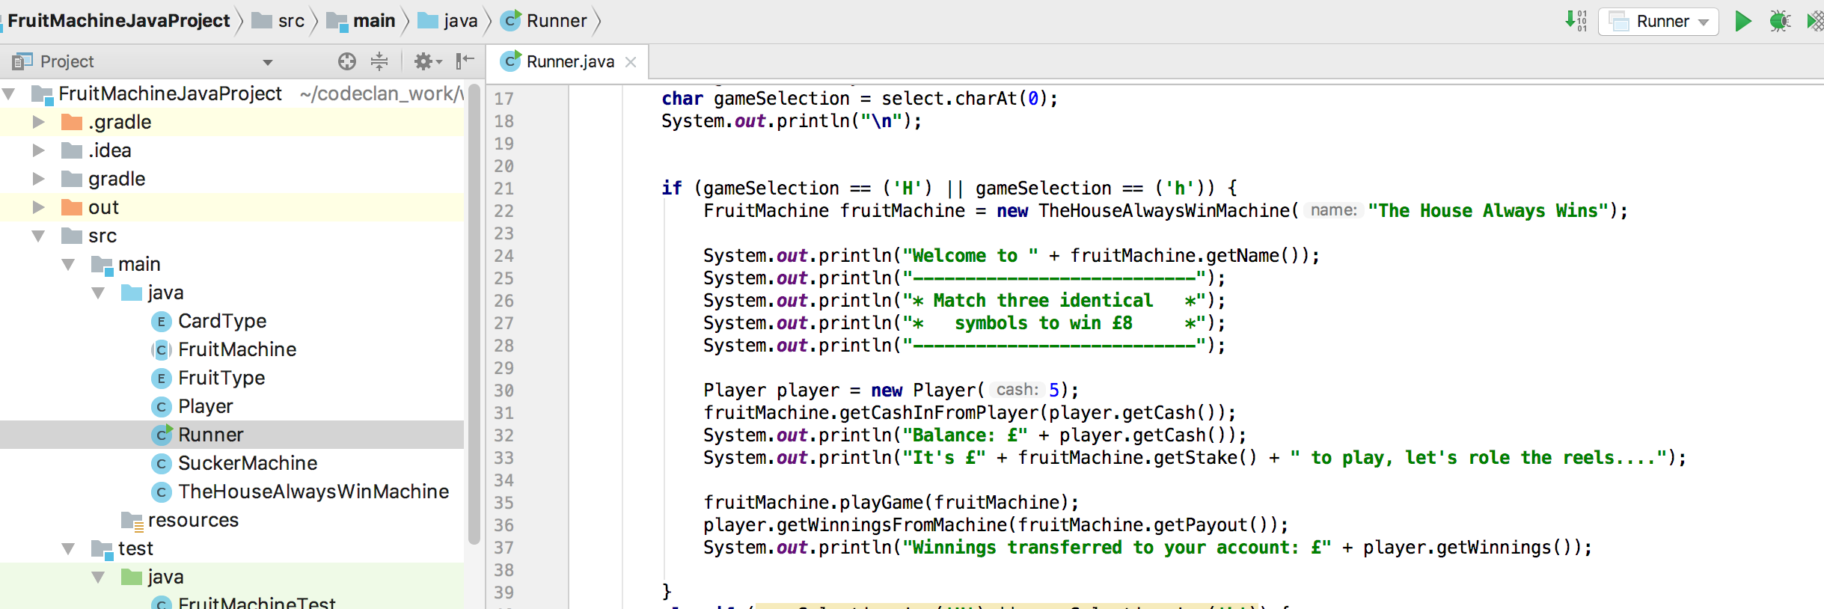

Cash is saved and then reduced as the game is played.

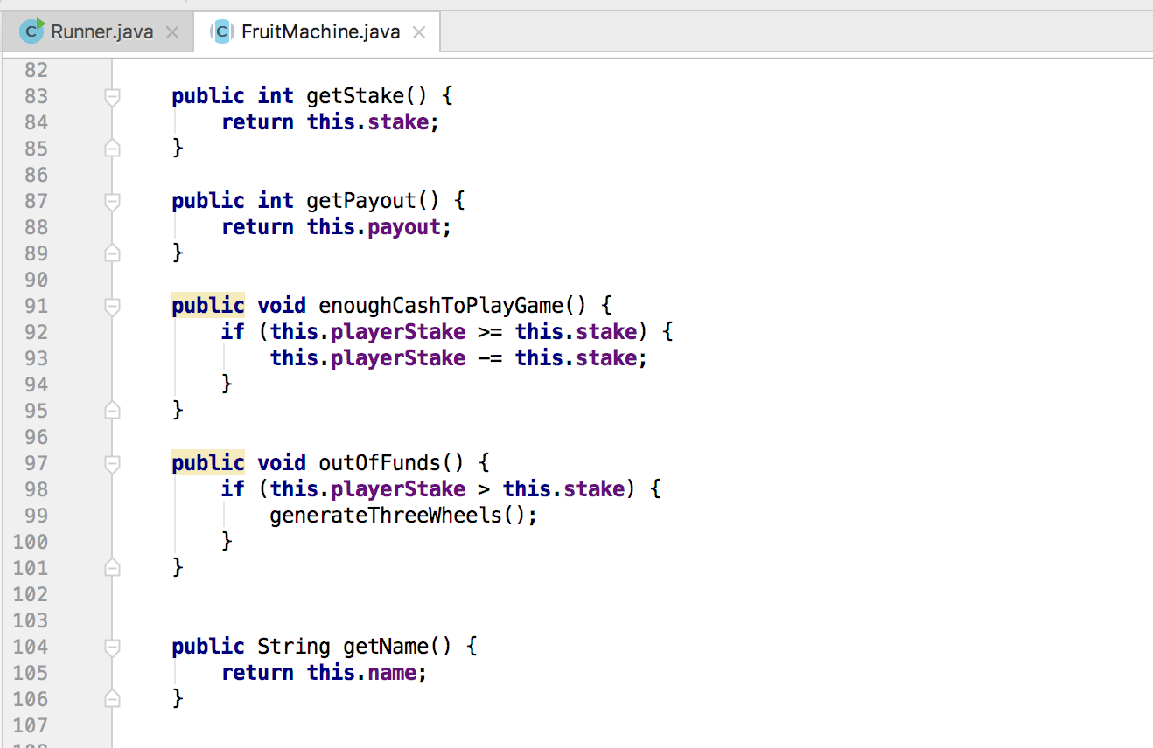

Confirmation that data being saved

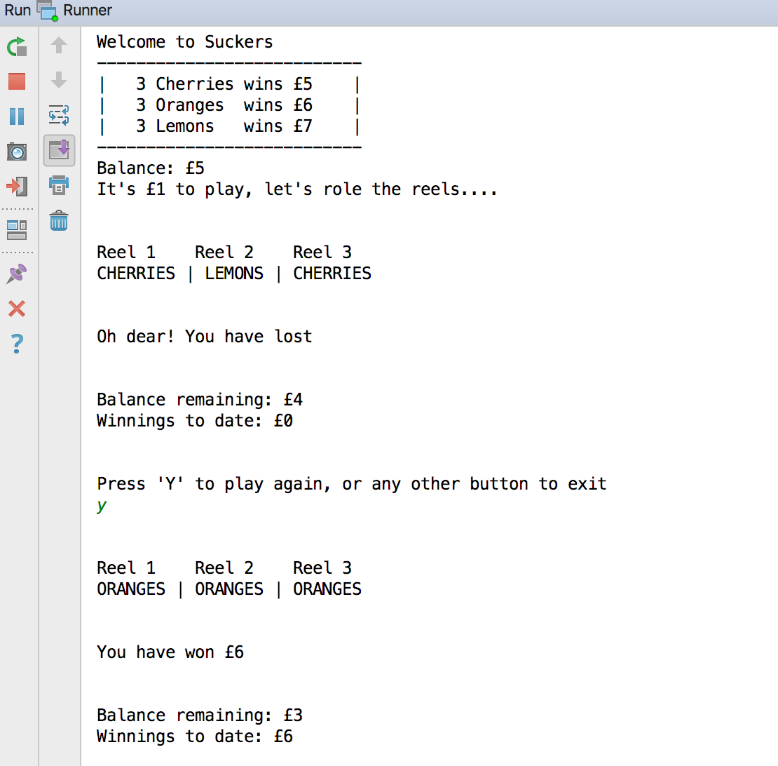

P. 15 User output result

Ruby project – shop inventory

Showing products before user input

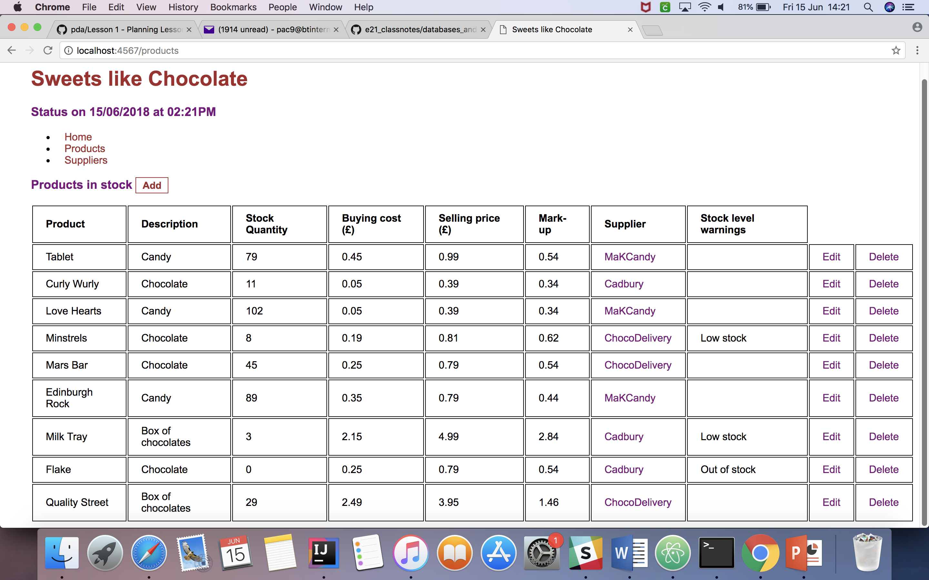

Add new product

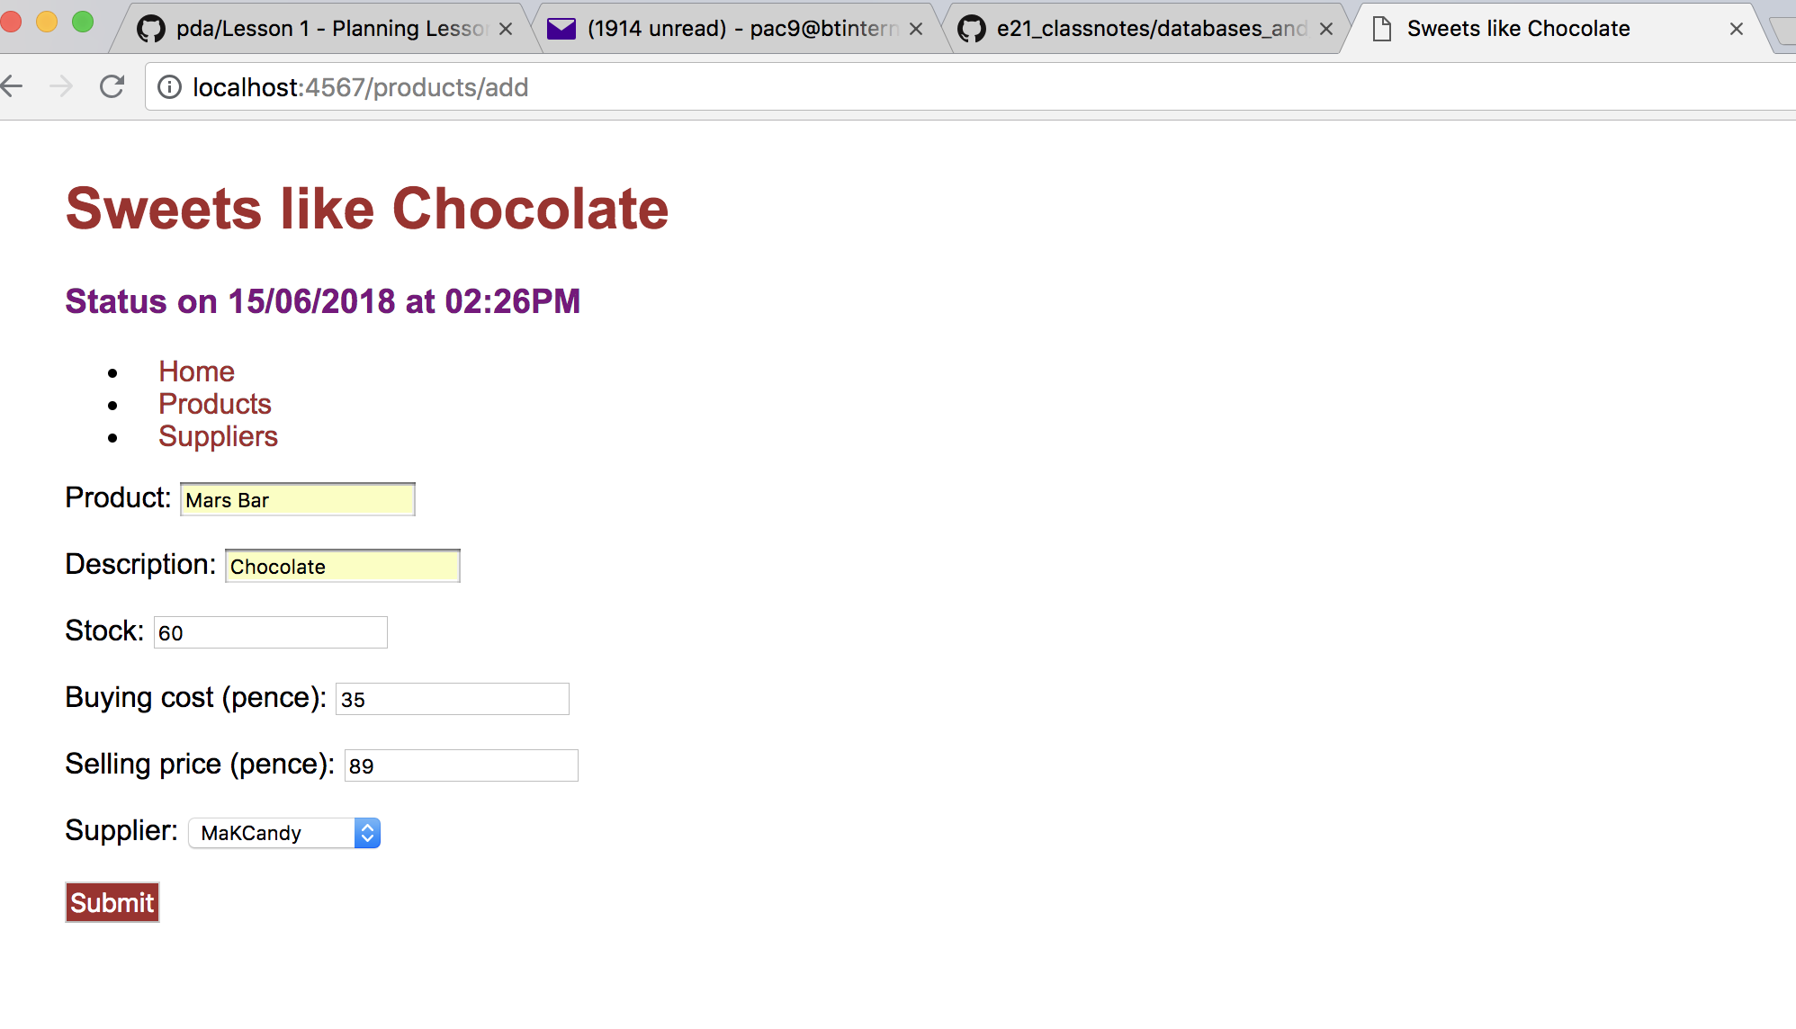

New stock added

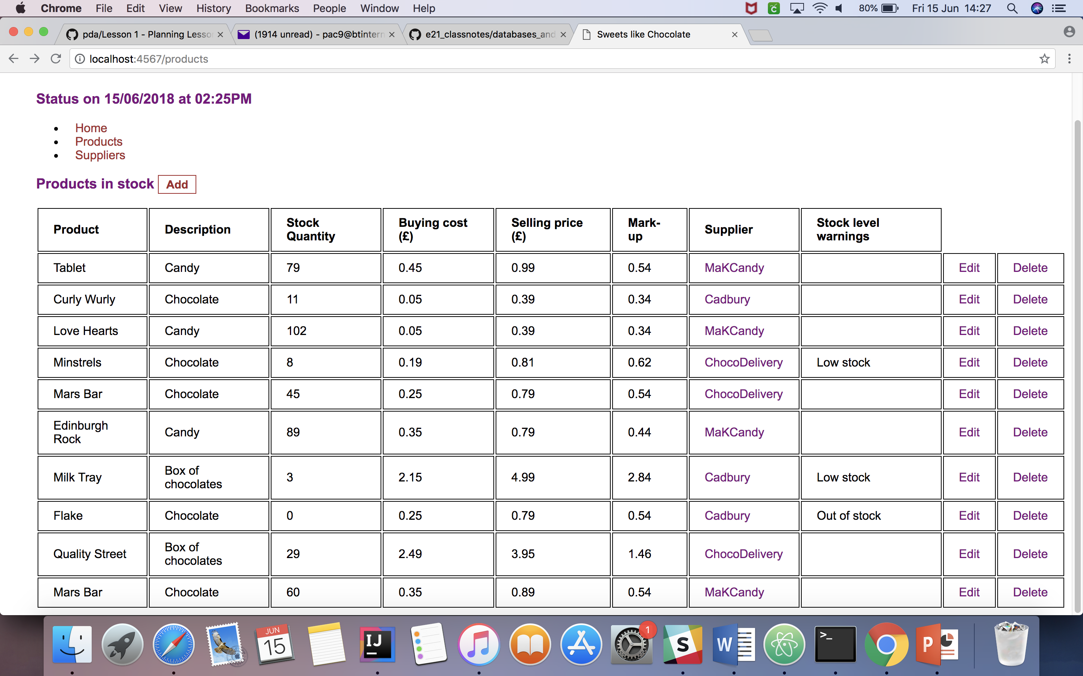

P.16 Show an API being used within your program

File- javaScript-React-LyricsAPI – all day lab Week15 Day 3

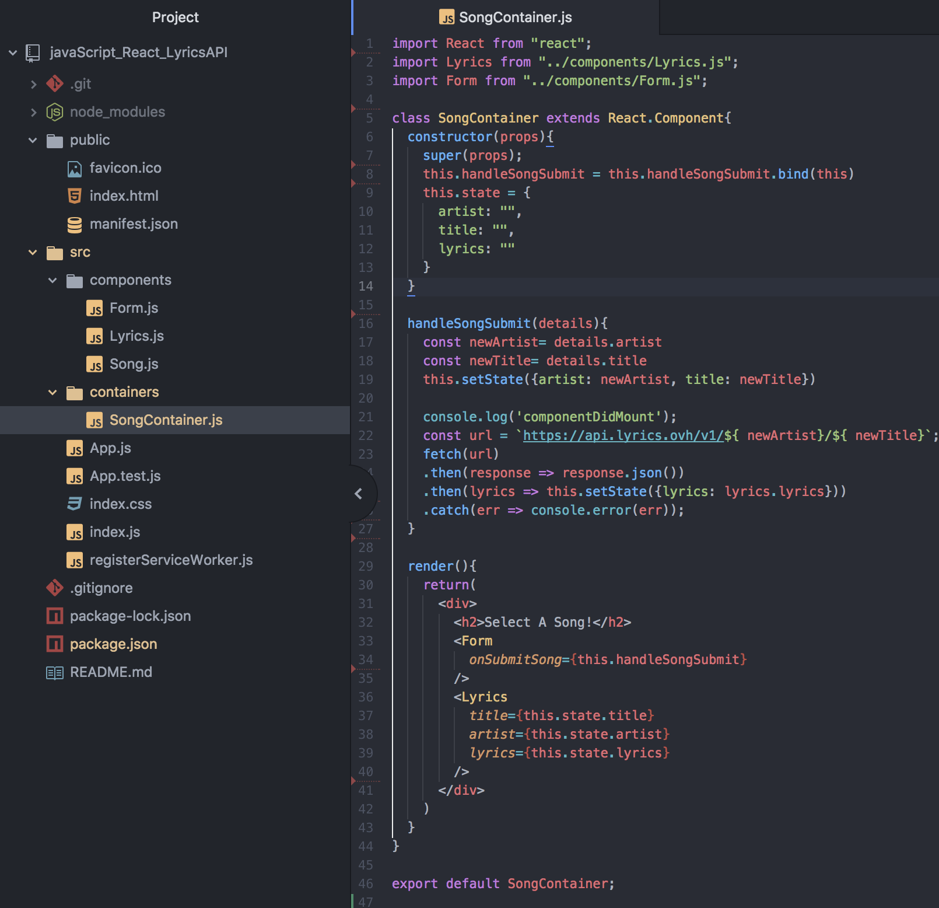

Homepage of app

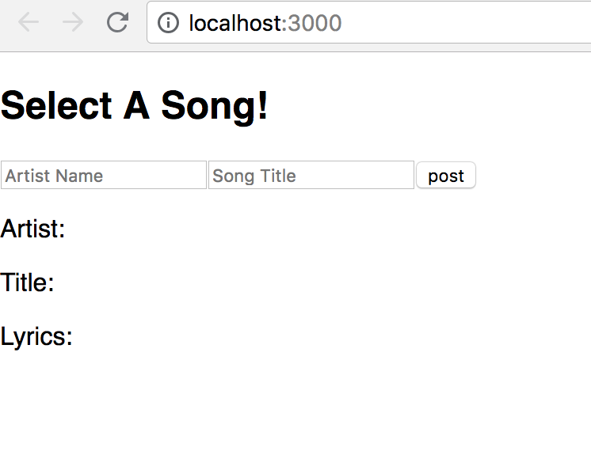

App working

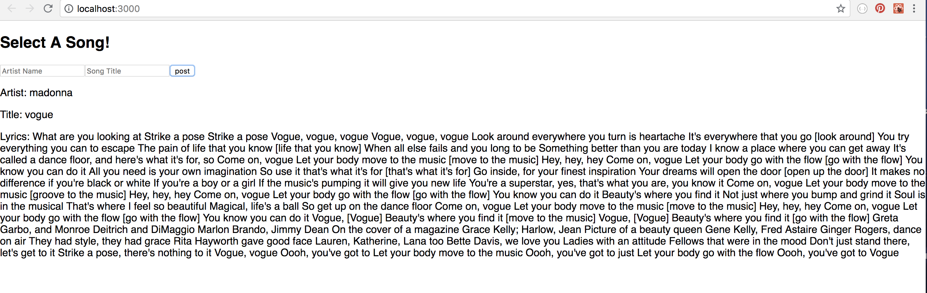

P. 17 Bug tracking report showing the errors diagnosed and corrected.

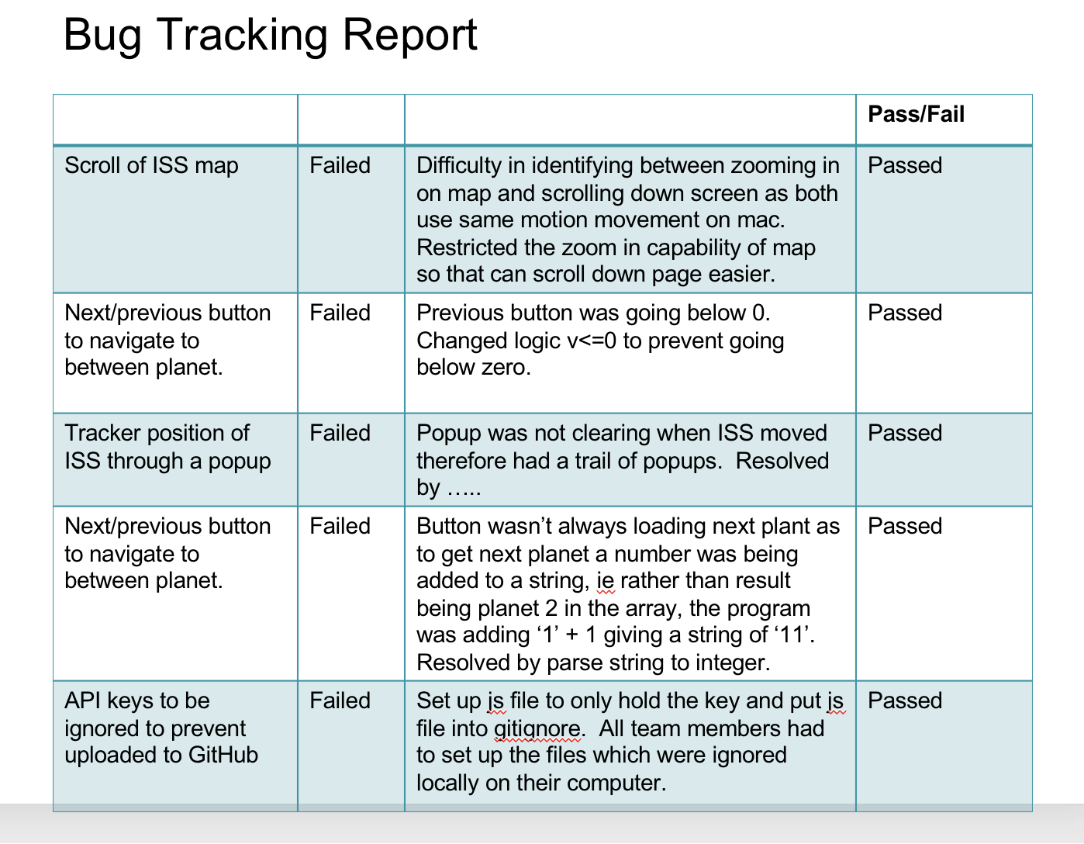

P. 18 Testing your program

Show the test code, the test not passing…..and then the test fixed.



Evidence for unit

P18

Card file before changes

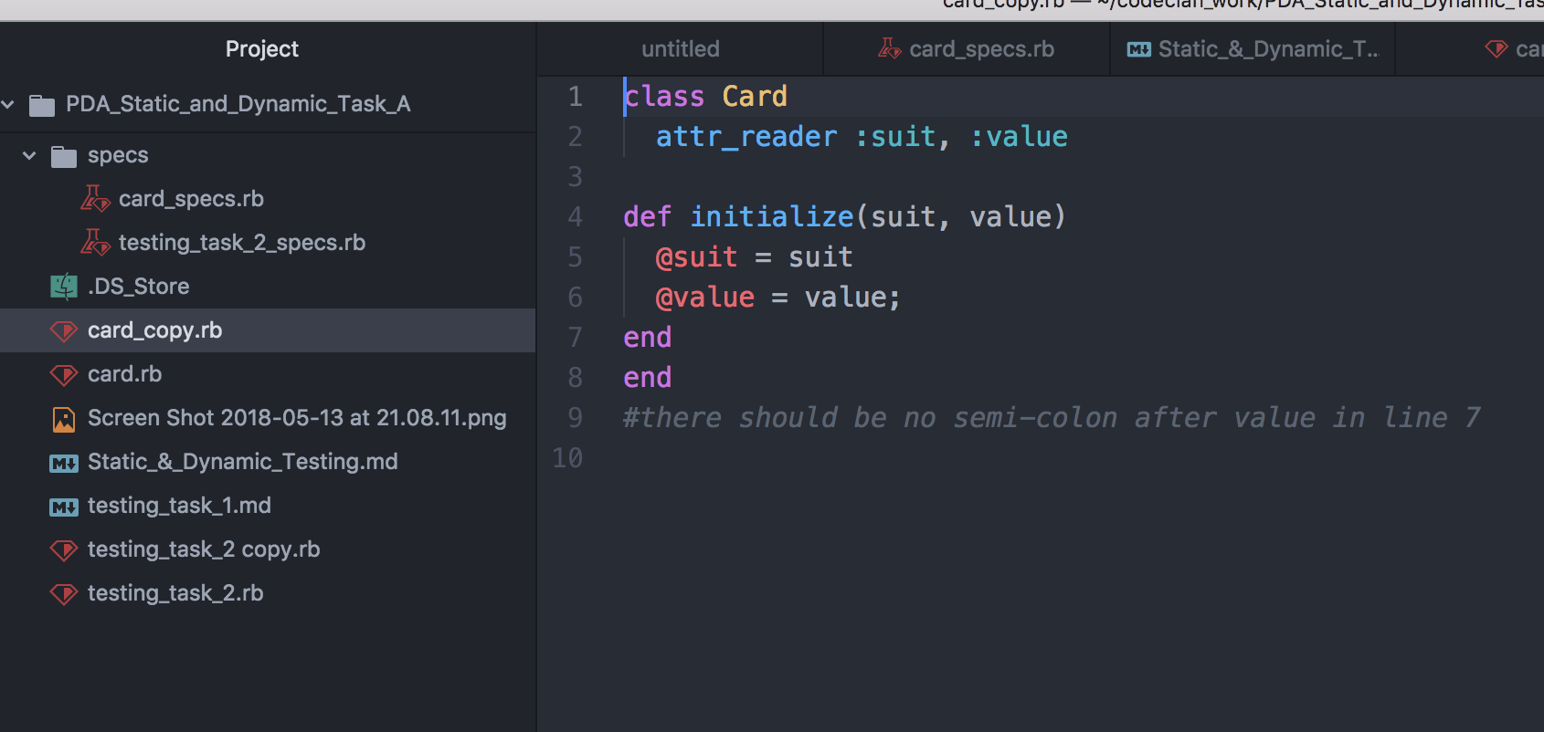

Card test file before changes – test passed regardless of syntax error highlighted

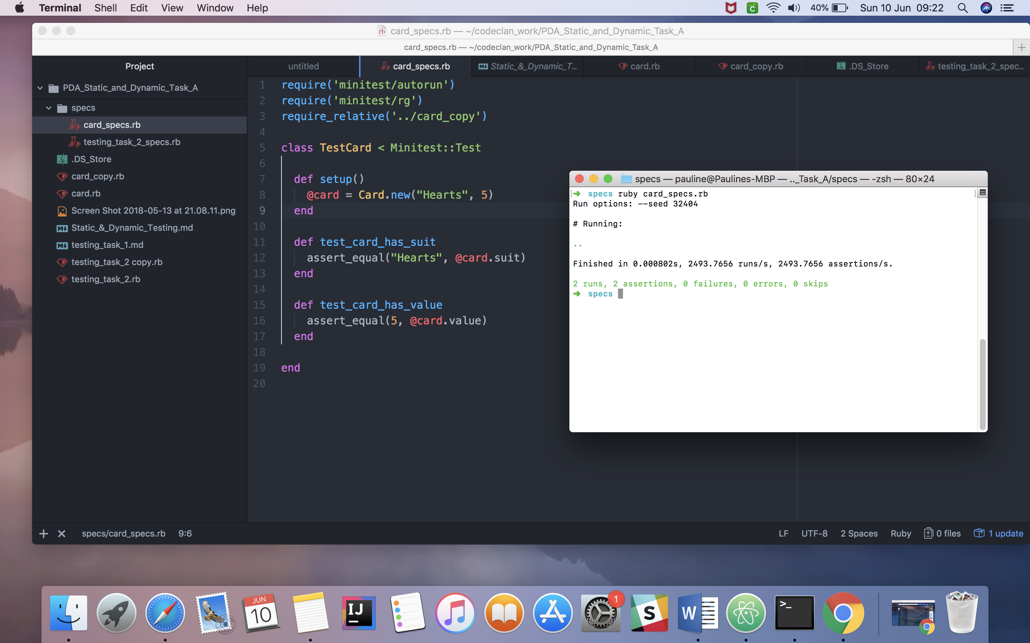

Card file after update

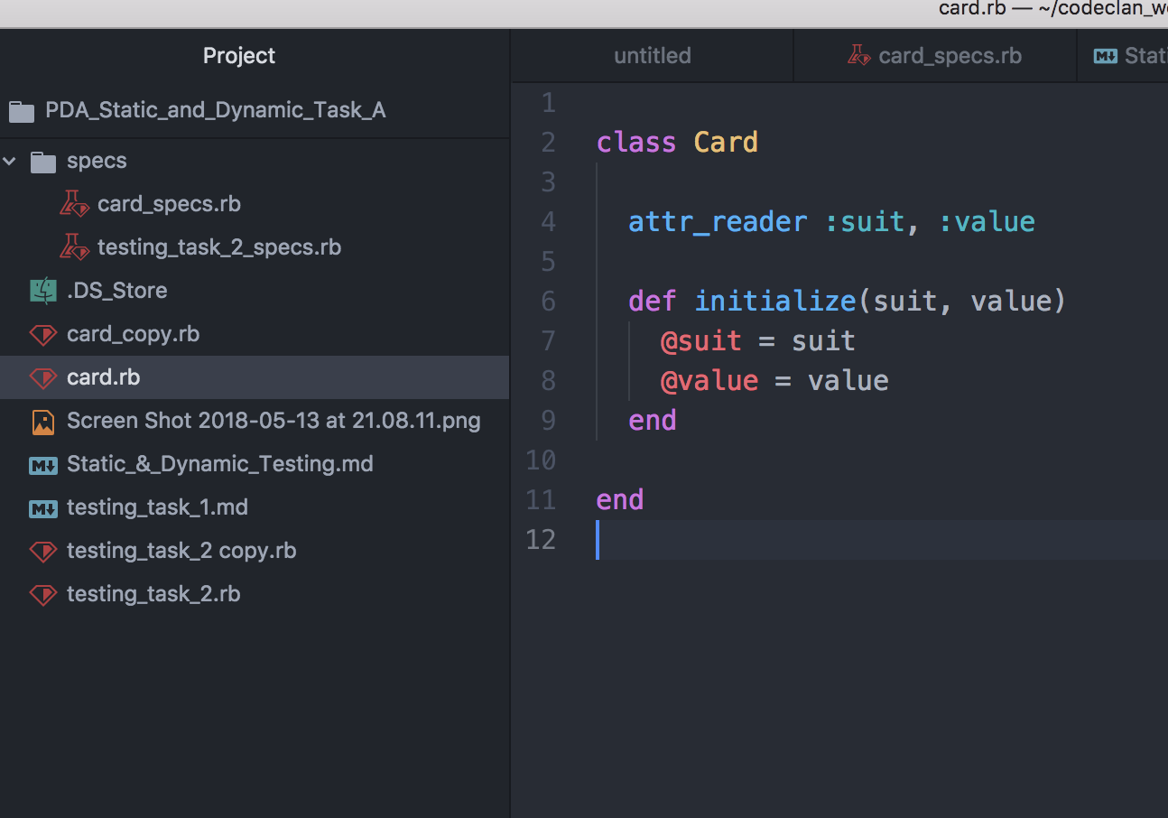

Card test file after update

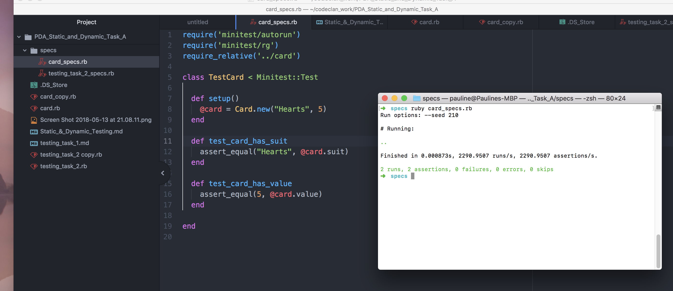

CardGame comments re errors in program before fixing

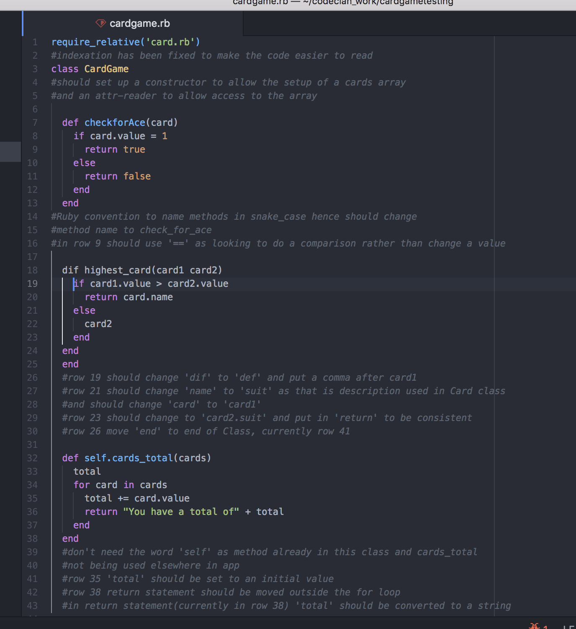

CardGame specs failing before fixing errors

Specs file won’t run due to extra ‘end’ in cardgame.rb file

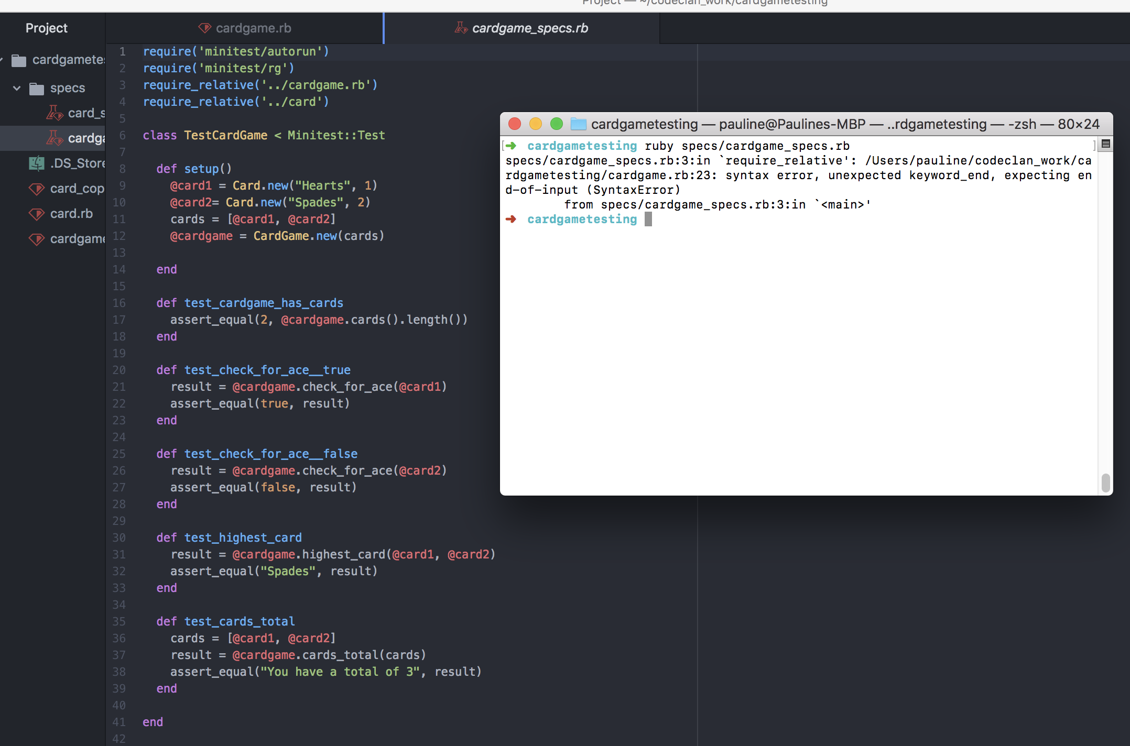

CardGame once changes made

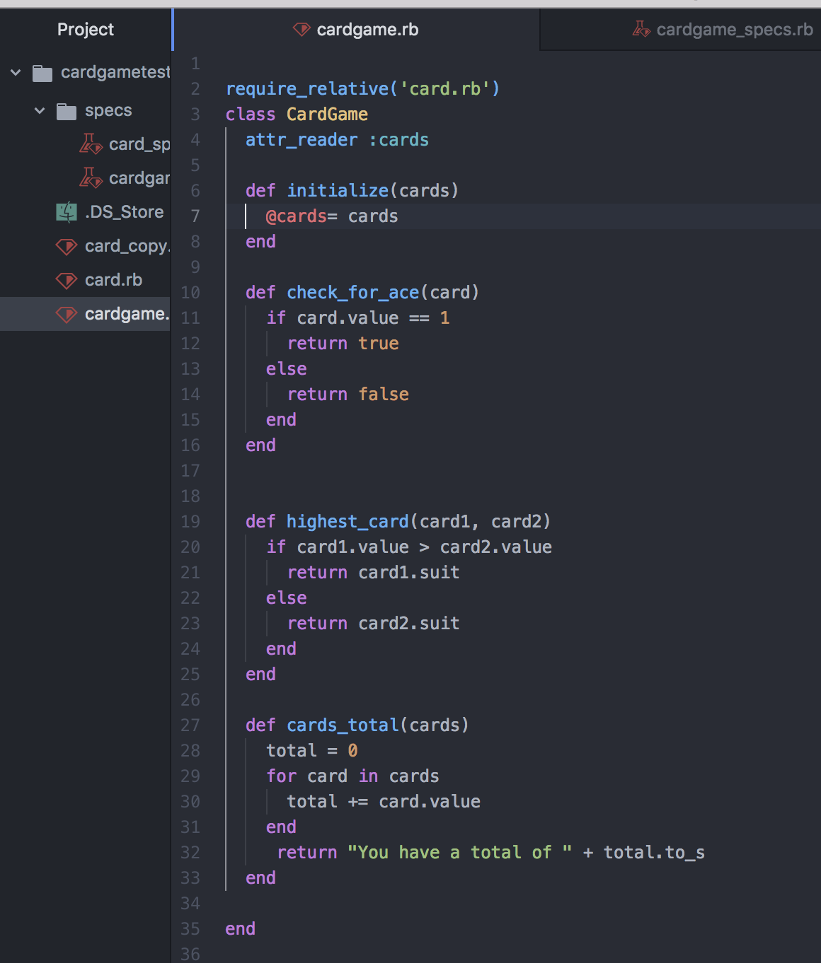

CardGameTests passing

